A Reflection on The Development of Wellness Town

Author: Ben Higham
Date: 08/01/2025
Contents
Table of Figures 3
1.0 Introduction 4
2.0 About the Client 4
2.1 Analysis and Evaluation of the Client’s Needs 4
2.2 Limiting Factors and Product Scope 6
2.2.1 Analysis and Evaluation of the Limitations and Scope 6
3.0 The Development Process 7
3.1 The Development Team 7
3.2 Agile 7
3.3 Communication with the Client 8
3.4 The Product Design and Genre 8
4.0 Reflection on the Project 8
4.1 Personal Contribution to the Project 8
4.2 Player Character Development 9
4.2.1 Introduction 9
4.2.2 PlayerCharacter Class 10
4.2.3 PlayerController Class 11
4.2.4 PlayerMovementComponent Class 11
4.3 AI Development 12
4.3.1 Introduction 12
4.3.2 Goal-Oriented Action Planning 12
4.3.3 GOAP_Agent Class 13
4.3.5 GOAP Strategies 15
5.0 Conclusion 17
References 18

Table of Figures
Figure 1: Graph Showing the Flow of the Game Loop 4
Figure 2: Screenshot of Animal Crossing to Show the Art Style 5
Figure 3: Benefits of Belonging 5
Figure 4: Screenshot From the Prototype Showing the Empathy Visual Effect 6
Figure 5: Example of Floating Interact UI in Roblox 7
Figure 6: Flowchart Showing Agile Workflow 8
Figure 7: Early Placeholder of Journal 9
Figure 8: Image Showing Drawn Trajectory 11
Figure 9: Image Showing Code to Create a Spline 11
Figure 10: Image Showing Code to Draw Trajectory 12
Figure 11: Image Showing Input Functions in the PlayerController 12
Figure 12: Image Showing BeginPlay in GOAP_Agent 14
Figure 13: Image Showing the Code that Calls the CalulateActionPlan Function 14
Figure 14: Image Showing the CalculateActionPlan Function 15
Figure 15: Image Showing How the Goap_Agent Handles _currentAction if it Exists 15
Figure 16: Image Showing AbstractStrategy Functions 16
Figure 17: Image Showing the Benefits of Decoupling Actions From Strategies 16
Figure 18: Image Showing Start Function in BugCatcherWorkStrategy (BCWS) 17
Figure 19: Image Showing Update in BCWS 17
Figure 20: Image Showing Stop Function in BCWS 17

Introduction
Throughout this module, the team was tasked to develop a fully functional prototype of a game (Wellness Town) that met a client’s demands. Within this report, detail will be provided about the client and what their goals are. Any product requirements they listed, and some information about how the team handled those requirements, will then be covered. The report will then provide some insight into the development team itself, and how the development of the product was handled over the 6-week period. Finally, the author will go into detail about their personal contributions to the product.

2.0 About the Client
At the start of the module, our client, Dr Paul Watson (who is the Research Coordinator for the Games department at the University of Greater Manchester) came to the team with a prototype of the project (which showcased some early implementations of systems, such as interaction, dialogue and quests) and explained his intentions behind the product and what he hoped to achieve.
The aim of the client is to develop an RPG (Roleplaying Game) targeted towards younger players (8-11 years old), that helps to improve the wellbeing of the player by “using an interactive task-based and reflective approach to develop skills for use in daily life” (Paul Watson, 2024).
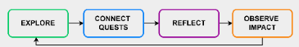

Figure 1: Graph Showing the Flow of the Game Loop
The client has frequent discussions with researchers and psychologists and, going forward with development, will use the product to gather data (from players) to aid these researchers and psychologists with their research.

2.1 Analysis and Evaluation of the Client’s Needs
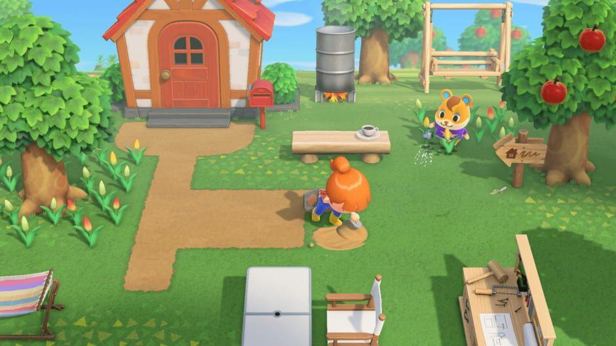
When planning the development of the product, the team had to take the target audience into considering. As the client wants the game to be targeted towards younger players, the team had to make sure that any mechanics and interactions added to the game were kept simple and easy to understand.
Furthermore, the artists had to make the game look appealing to a younger audience by using: vivid colours, as the “presence of vivid colours and relatable subject matter were the main image elements that stimulated children’s interests” (Irene Lopatovska, 2016); and simple geometry that would appeal to younger players.
Figure 2: Screenshot of Animal Crossing to Show the Art Style
The client’s focus is on encouraging players to take notice of the people around them, and to help people if they can. They expect the product to put the player in an environment that promotes this idea, by having interactable NPCs (Non-Player Characters) in the world that will display hints to how they are feeling and provide quests, and dialogue, to allow the player to help them with their problems.
As the aim of the game is to make the player take notice of the people around them, the team decided to emphasise interaction wherever possible. The team wanted the player to feel like they were within a community, so having varying types of NPCs that actively perform tasks (such as jobs and hobbies) specific to their personalities, as well as an interactable world filled with items that the player can: pick up, throw, move around, and use; would be critical to make the player feel like they were involved in a functional community. Although the community would not be real, it is possible that players engaging and being a part of the community would bring them a sense of belonging, and therefore have positive effects on their mental wellbeing (Mandy Wan, 2023)
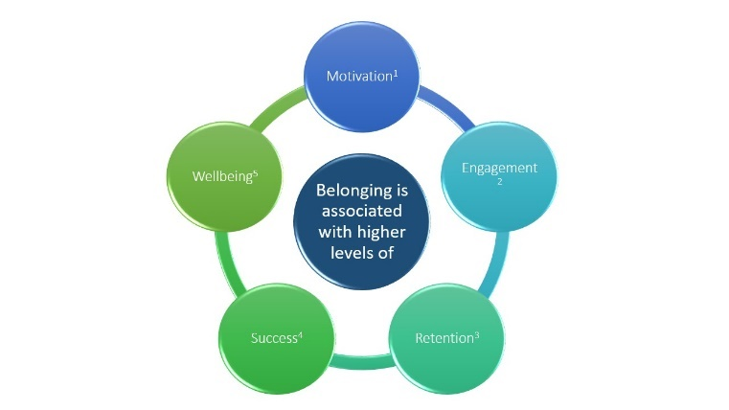

Figure 3: Benefits of Belonging

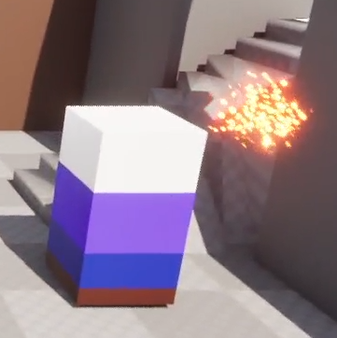
Furthermore, these NPCs would have to show some signs of their emotional wellbeing so the player could take note of these signs to help progress through the game. The team decided that, as with the prototype provided by the client, dialogue would enhance the player’s experience of being involved in a functional community environment. Furthermore, the team also liked that the prototype has subtle graphical elements that would be displayed above NPCs to hint at their emotional wellbeing.

Figure 4: Screenshot From the Prototype Showing the Empathy Visual Effect

To further support both the community and wellbeing elements, the team wanted to create a Journal system that would display what each NPC liked and disliked. These likes and dislikes would only be discovered through talking with the NPCs and completing quests specific to them, and knowing these would develop a relationship between the player and each NPC in the community. Furthermore, each NPC would also have a Trust and Friendship score associated with them. The player can improve these scores by learning knew things about the NPCs and helping them through quests. Improving Trust and Friendship will affect the interactions between the player and the NPC.

2.2 Limiting Factors and Product Scope
As the client expects a playable demo after a 6-week development cycle, the team won’t have a significant amount of time to plan and prototype ideas thoroughly and will have to keep systems relatively simple to maximise efficiency.
Furthermore, because the game is targeted towards a younger audience, the team had to make sure that any mechanics were not only simple, but explained within the game in a way that would not break immersion. Aside from the complexity of mechanics and gameplay, the narrative of the game would have to be easy to understand and supported by visual storytelling instead of relying on dialogue.

2.2.1 Analysis and Evaluation of the Limitations and Scope
Due to the short development time, the team had to scope carefully to produce a playable product that fulfilled the client’s requirements, without overreaching, to avoid an unfinished or unplayable product.
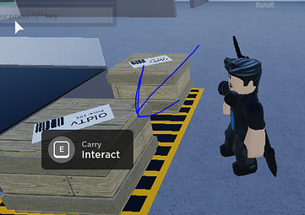
In terms of mechanical complexity, having the game targeted towards a younger audience; and therefore, having to ensure the mechanics were easily understood by a younger player base, was a benefit to the team as we were limited by the timeframe, and had to keep things simple already. A long with simple mechanics, the team had to make sure that the player learned how to utilise the mechanics in a non-immersion breaking way. This could be done through dialogue with NPCs, and visual cues (such as button indicators on screen).
Figure 5: Example of Floating Interact UI in Roblox
Along with mechanical complexity, the team also had to make sure that the narrative was not heavily text/dialogue focussed (as this wouldn’t be engaging for 8-11 year olds), but also included a lot of visual storytelling. The team utilised VFX (Visual effects) to display NPC moods when necessary and produced art assets (such as homes) that matched the style of the NPC that owned them.

3.0 The Development Process
After receiving the client’s pitch, the team came together to discuss the roles of each member, as well as any ideas each member had. We then reached out to Dr Watson and pitched the ideas to him to get feedback and ensure that they suited his aims for the project.

3.1 The Development Team
The team behind Wellness Town consists of 6 dedicated developers (two programmers, two designers, and two artists) as well as two external artists who would aid development while also working with a second development team.
The structure of the team was simple. The project lead, who oversaw the development process, managed the organisation of tasks and communicated with members when needed. Although their main communication was to the lead members of each team. The lead maintained a workspace that contained any tasks and their state (backlog, to do, in progress, needs testing, done) and handled any documentation relevant to the project. There were then three smaller teams: Artists, Designers and Programmers; that each had a lead member. The lead would handle most communication between each member of the team and aid the project leader with task assignment and documentation. Finally, each member would work on tasks assigned to them (and take on any additional back-log tasks if they were able to) and ensure that their lead and/or the project leader were informed about their progress.

3.2 Agile
To aid with organising the team, the project lead chose to implement the Agile Methodology. The Agile methodology is a project management methodology “in which work is completed and delivered in short cycles (sometimes called sprints) and tweaked over time. This is done with the goal of providing value through increasing performance results as well as improving the structure of the project plant” (Caldwell, 2021).
Each week of development was split into its own Sprint, which is a short development cycle that consists of: Planning, implementing the plan, testing the implementation, and then the project lead and/or the lead members would review any completed tasks, and then give feedback or discuss what needs to be done next with each member (Sondra Ashmore, 2014).
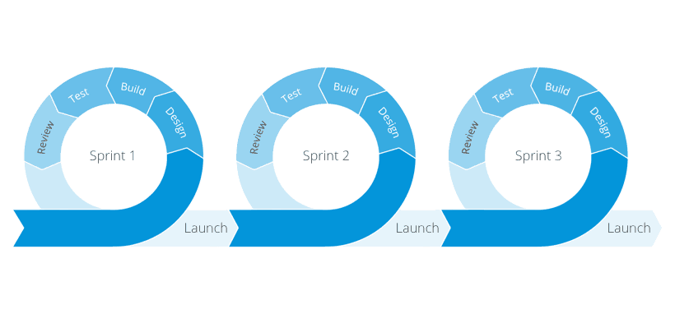

Figure 6: Flowchart Showing Agile Workflow

This system benefited the team greatly as each member was getting consistent feedback on their work because of the frequent testing.

3.3 Communication with the Client
To ensure that development was progressing in a way that suited the client’s need, the team held periodic meetings with the client to discuss the current implementations, what is planned, and any ideas that either the team or the client had.
This was very beneficial to the team and the development process as the whole as it ensured that ideas that did not align with the aims of the client were implemented into the game (this would mean development time was wasted), and it also allowed a consistent communication between the team and the client which minimised any confusion for both parties.

3.4 The Product Design and Genre
Due to the limitations highlighted in 2.2, the product had to be kept simple but also engaging for younger players to prevent them losing interest. The team, as requested by the client, created a Social Simulator game which can be defined as an “Immersive Computer Gaming Application to Boost Wellbeing” (Watson, 2024).
As the team wanted the game to have vivid and simplistic art style, games like Animal Crossing were a huge influence. Furthermore, the team also wanted a lot of exploration and NPC interaction in the game, so inspiration was taken from games like Pokémon and Stardew Valley.
Having completed the project, the genre and overall design of the product was a great choice for providing a game that would fulfil the client’s requirements. A Social Simulator game is perfect for a game that aims to promote empathy and meaningful interactions between people, as the genre is defined by its interactions with characters (player controlled or not).

4.0 Reflection on the Project
Overall, I think the development of the project was successful. As a team, we achieved a functional protype that fulfilled the client’s requirements and will act as a starting point for future development, with few issues within the team.

4.1 Personal Contribution to the Project
At the start of development, I was tasked with recreating mechanics related to the player that was seen in the prototype the client had developed, as well as a few additional mechanics that we wanted to utilise in the game. This included: Movement, Interaction, Mantling, Object Push and Pull, and item mechanics (pick up, use, throw, drop). These implementations were significant for the development of the product, as not only was a player character necessary, but the Mantling and Object Pushing and Pulling would be needed for world traversal, quests and puzzles.
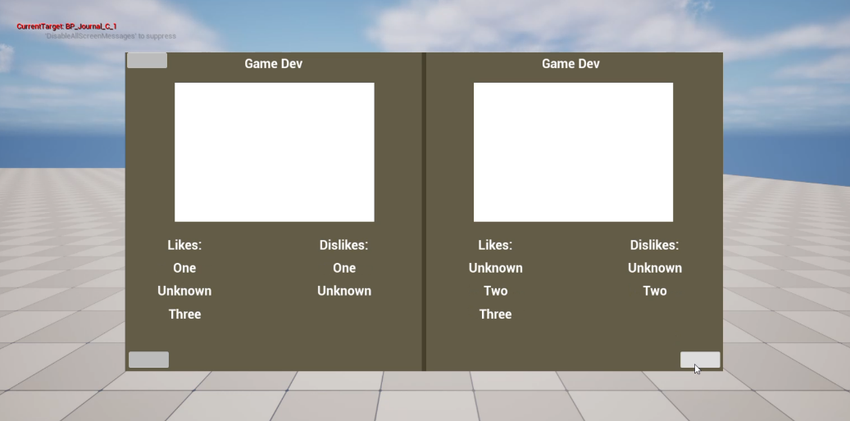
Once a functional character was created, I was then assigned tasks to create some things to interact with. I created a Journal, with the relevant data classes needed to handle Journal-related data, as well as a fishing rod and a bug catching net that could be used both by the player and AI. These items not only provided the player with more things to interact with, but having the AI being able to use them also brought more variety to the community we wanted to create. This is because we could have NPCs that go fishing and search for bugs to catch, as well as opening the possibility for future jobs and hobbies.

Figure 7: Early Placeholder of Journal
After these implementations were tested and approved. I was then tasked with creating the AI for the NPCs in Wellness Town. The AI is an important element in Wellness Town as it brings together the community atmosphere that the team was aiming for, and “AI is responsible for drawing the player into the game environment” (Jeremy A. Glasser, 2004). The AI is also what controls the NPCs that the player will interact with, and NPCs are a major component of a Social Simulator. Because of this, AI took up the bulk of my development once it was started, as I had to ensure that the system was complex and easily scalable to allow multiple NPC specific behaviours, both for the current product and future development.
To achieve this, I decided to implement a Goal-Oriented Action Planning (GOAP) form of AI, as GOAP was created to mimic more human-like, realistic behaviour because the “planning process is somewhat similar to the way in which humans reason when looking to satisfy a goal or task” (Long, 2007).
As well as complex AI for human NPCs, I also created a basic unstructured AI for the Bugs in the game. Bugs simply had to spawn in the world (via a Bug Spawner) and randomly fly around for the player (or NPCs) to catch.
Although AI was my focus at this point, I also added a Minimap as they “provides important information to make the right decisions during the game and plays an important role in navigation in different game genres” (Krzysztof Zagata, 2023) and aided the team’s technical designer with any issues.

4.2 Player Character Development

4.2.1 Introduction
My first task was to develop the player classes and to incorporate and build on some features that were in the prototype provided by our client. I will discuss some of the features implemented in the PlayerCharacter class, the PlayerMovementComponent class, and the PlayerController class.

4.2.2 PlayerCharacter Class
The PlayerCharacter is the object that the player will see and control in the game when playing and contains the functions that the PlayerController will use when handling inputs. The PlayerCharacter class also contains any logic relevant to those inputs, such as drawing the trajectory that an item will follow when being thrown or cast (like a fishing rod).
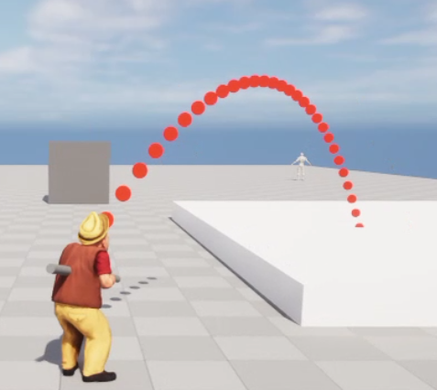

Figure 8: Image Showing Drawn Trajectory
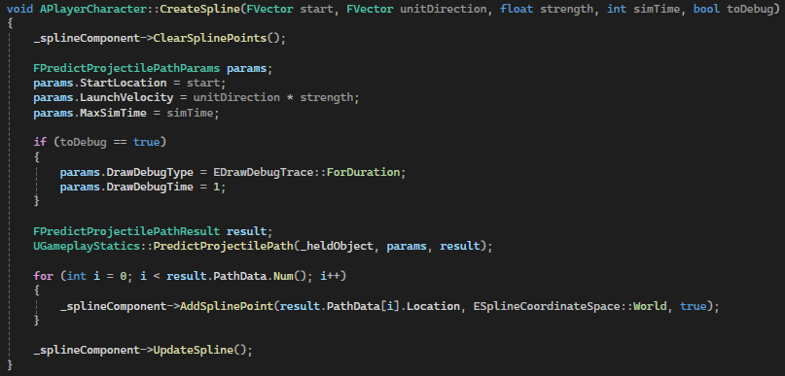
To draw the trajectory, I utilise a spline (which, in mathematics, is “a curve that connects particular points” (Cambridge, n.d.)) to create a curve of points based on a specified velocity and direction.

Figure 9: Image Showing Code to Create a Spline
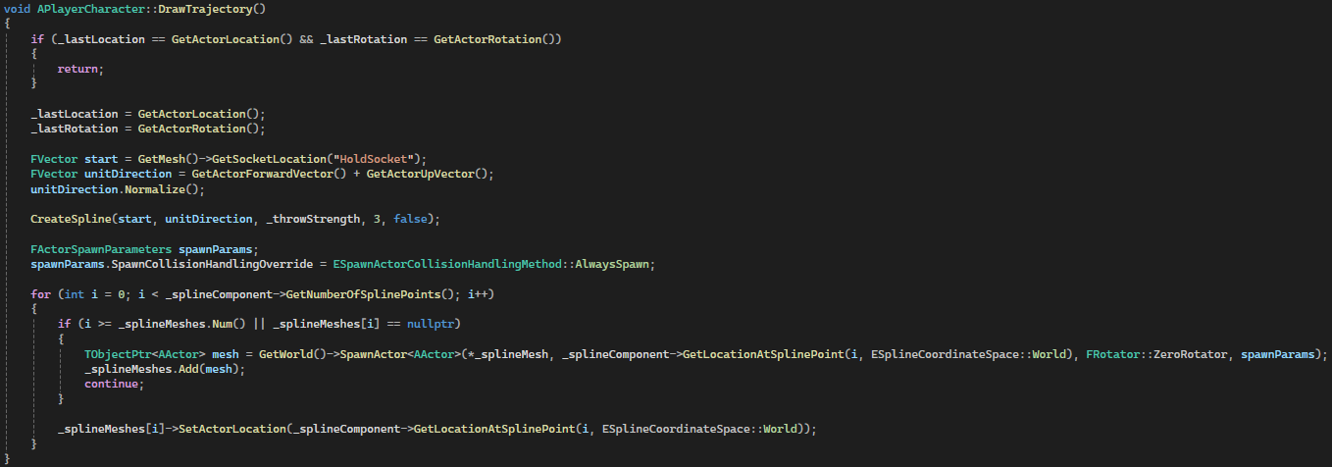
To display the curve, I spawn an Actor (which, in Unreal Engine, “is any object that can be placed into a level” (Epic Games, n.d.)) at each point along the spline. Currently, when the context to draw the trajectory is fulfilled, a pool of Actors is created to prevent old actors being deleted, and new actors being created, if the player moves (and the spline is recalculated), this improves performance (Georgios Koulaxidis, 2022). However, the actors are destroyed when the context has ended, I could further optimise this by having generated a pool of these actors at the start of the game and utilising those throughout the entire playtime.
Figure 10: Image Showing Code to Draw Trajectory

4.2.3 PlayerController Class
The PlayerController class handles all the inputs that the player will use. The inputs available are: Look (Rotate the camera), Move, Jump, Interact and Alt Interact, Drop, Cast (Use item if possible), and Throw.
When an input is used, the PlayerController class communicates with the PlayerCharacter class to trigger any functions relevant to the input.
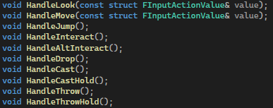

Figure 11: Image Showing Input Functions in the PlayerController

4.2.4 PlayerMovementComponent Class
The PlayerMovementComponent class handles the movement style of the player as well as the movement-related animations. I decided to create a custom CharacterMovementComponent (as Unreal Engine has one by default) to allow the implementation of Mantling (climbing on to objects), as well as to add a custom movement mode when the player is pushing or pulling an object.

4.3 AI Development

4.3.1 Introduction
My main commitment to the project was developing the AI and the relevant systems necessary for its functionality. I will briefly talk about the components used to develop the AI, any specific rationale behind the decisions I have made, and how it all links together to work in the product.

4.3.2 Goal-Oriented Action Planning
Goal-Oriented Action Planning (GOAP) was first developed by Jeff Orkin in the early 2000s when working on the game F.E.A.R , released in 2005, (Jacopin, 2015) and ) “is a decision-making architecture that takes the next step, and allows characters to decide not only what to do, but how to do it” (Orkin, Applying Goal-Oriented Action Planning to Games , 2003).
There are four main components to consider when creating a GOAP AI: Goals, a condition that the AI agent wants to satisfy; Actions, a single element within a plan that makes the agent do something; Plan, a sequence of actions that satisfies the agents goal in the end (Orkin, Applying Goal-Oriented Action Planning to Games , 2003); Beliefs, what the AI agent knows (or believes) about the world around it.
In GOAP, actions can have preconditions, effects, and a cost. Preconditions and effects are beliefs. A precondition is a belief that the agent must have to perform the action, and the effect is how the agent’s beliefs will change once the action is performed (Orkin, Three States and a Plan: The A.I. of F.E.A.R., 2006). The cost is used for planning if multiple actions can achieve the same goal, a higher cost action will be avoided, so cost simulates the energy (or some other cost) that the agent will use to perform the action (Orkin, Three States and a Plan: The A.I. of F.E.A.R., 2006).
The planner produces plans that will achieve the agent’s goal (if possible). The planner creates a node graph using the actions as node, and the preconditions and effects as edges. The planner will then use a chosen search algorithm (such as A*) to iterate through the node graph to try and find a path of actions that lead to the desired goal (an action whose effect matches the goal). If a path exists, the plan is returned to the agent to be worked on.

4.3.3 GOAP_Agent Class
The GOAP_Agent class is what handles the behavioural AI of NPCs that have the component attached. It creates its beliefs, actions and goals and works through a plan if it has a valid one (and requests a plan if it does not).
Once the GOAP_Agent is created and is in a level (BeginPlay), it will setup its beliefs, actions, and goals, as well as creating a GOAP_Planner object.
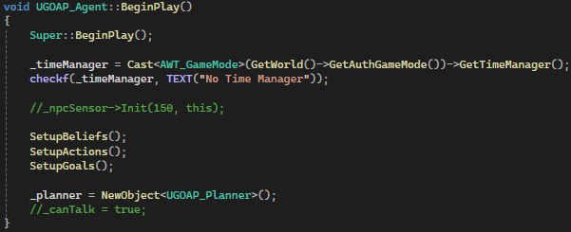

Figure 12: Image Showing BeginPlay in GOAP_Agent

After the initial setup, most of the logic will then be performed every tick (“"Ticking" refers to running a piece of code or Blueprint script on an actor or component at regular intervals, usually once per frame” (Epic Games, n.d.)).
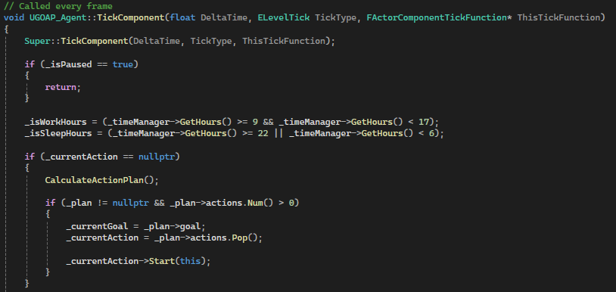
If the agent is not paused, it will first check if it has an action to perform (_currentAction). If it does not, it will calculate a new plan.
Figure 13: Image Showing the Code that Calls the CalulateActionPlan Function
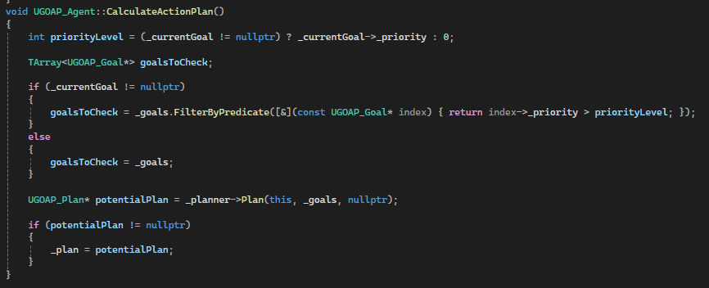
Figure 14: Image Showing the CalculateActionPlan Function

Once the agent has a plan and an action to perform, the agent will then call the Update function on the action which will execute the logic within the actions strategy. Once the action is complete, the agent will end the _currentAction and take the next action in the plan if one exists. Else, it will set the _currentAction to nullptr and the previous step will be executed.
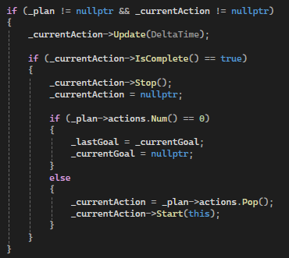

Figure 15: Image Showing How the Goap_Agent Handles _currentAction if it Exists

4.3.5 GOAP Strategies
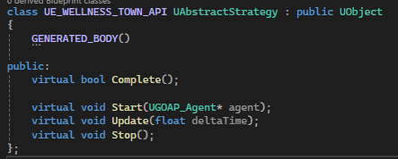
To contain the logic within each action that the GOAP_Agent performs, I used Strategy classes. Each strategy derives from the AbstractStrategy class, that contains Complete(), Start(), Update() and Stop() functions.
Complete() checks whether the condition to fulfil the effect is true.
Start() initializes the strategy.
Update() simulates ticking within the strategy.
Stop() executes when the strategy is complete.

Figure 16: Image Showing AbstractStrategy Functions
Using strategies decouples the logic that the AI performs within an action, from the creation of and handling of the action itself. This means that it is far easier to create new actions with different tasks to perform, to change the task that an action contains, and to make changes to the task logic without affecting the action itself.
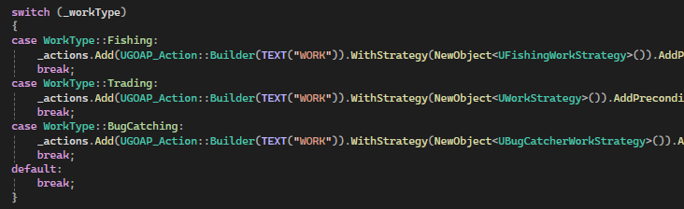
To show an example of a strategy, I’ll breakdown the BugCatcherWorkStrategy, which is assigned to the work action of an agent if they are Bug Catchers (the below figure highlights a benefit of the decoupling, as the same action can contain different strategies based on the context of the agent).

Figure 17: Image Showing the Benefits of Decoupling Actions from Strategies

When the BugCatcherWorkStrategy (BCWS) is started, the _agent and _npc values are set and a check is done to determine whether a _bugNet exists for the agent to use. If not, one is spawned. The BugNet is then set to be visible and attached to the NPC (the NPC “picks” it up).
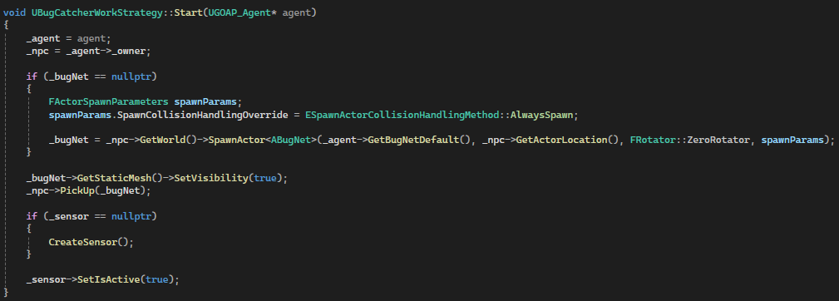
A sensor is then created to aid the work being performed.
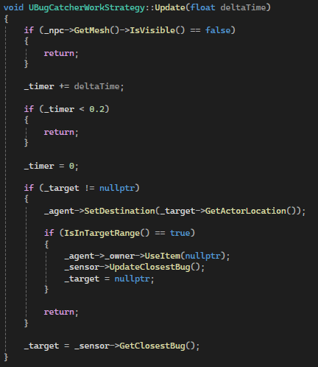
Figure 18: Image Showing Start Function in BugCatcherWorkStrategy (BCWS)
Next, in the Update (ticking) function, there is a check to see if the strategy has a bug target for the agent to chase, if not; the strategy queries the sensor to check for any bugs that it is colliding with, and then return the nearest bug. If a target does exist, the agent begins to seek (chase) the bug and catch it with the Bug Net when it is close enough.

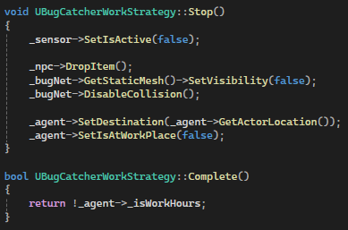
Figure 19: Image Showing Update in BCWS
Finally, when the strategy is complete (when it is no longer work hours), the sensor is set to inactive, and the Bug Net is dropped and hidden for future use.

Figure 20: Image Showing Stop Function in BCWS

5.0 Conclusion
In conclusion, the team was successful in providing a functional product that fit the client’s requirement, and within the specified 6-week timeframe.
The game is an RPG that encourages the player to be more aware of the world (specifically the people) around them, by having them observe each NPCs mood and to encourage interaction between the player and the NPCs through dialogue and questing. Furthermore, the complexity of the game is ideal for the desired target audience (8–11 year olds) and the visuals are simple but vivid to keep them engaged.
Personally, I’ve enjoyed working on Wellness Town and overcoming the challenges it presented to me, and the team. I am overall happy with my contribution to the product and look forward to developing it further if the client permits it in future. The game is also in a state that I am proud of, and hope to see or be a part of the final product.

References
Caldwell, G. (2021). Agile Project Management - The Complete Guide for Beginners to Scrum, Agile Project Management, and Software Development. Alakai Publishing LLC.
Cambridge. (n.d.). Spline. Retrieved from Cambridge Dictionary : https://dictionary.cambridge.org/dictionary/english/spline
Epic Games. (n.d.). Actor Ticking. Retrieved from Unreal Engine : https://dev.epicgames.com/documentation/en-us/unreal-engine/actor-ticking-in-unreal-engine
Epic Games. (n.d.). Actors. Retrieved from Unreal Engine: https://dev.epicgames.com/documentation/en-us/unreal-engine/actors-in-unreal-engine
Georgios Koulaxidis, S. X. (2022). Improving Mobile Game Performance with Basic Optimization. Modelling, 201-223.
Irene Lopatovska, S. H. (2016). Not just a pretty picture: visual literacy education through art for young children. Journal of Documentation, 1197-1227.
Jacopin, É. (2015). Optimizing Practical Planning for Game AI. In S. Rabin, Game AI Pro 2: Collected Wisdom of Game AI Professionals (pp. 117-127). A K Peters/CRC Press.
Jeremy A. Glasser, L.-K. S. (2004). AI in Computer Games: F AI in Computer Games: From the Pla om the Player’s Goal t s Goal to AI’s Role . Lincoln: University of Nebraska.
Krzysztof Zagata, B. M.-G. (2023). Mini-Map Design Features as a Navigation Aid in the Virtual. International Journal of Geo-Information, 1-16.
Long, E. (2007, September). Enhanced NPC Behaviour using Goal Oriented Action Planning. Dundee.
Mandy Wan, E. N. (2023, July 3). "It's More than Just a Game": How a Sense of Belonging is Fostered and Maintained in Video Games. Glasgow.
Orkin, J. (2003). Applying Goal-Oriented Action Planning to Games .
Orkin, J. (2006). Three States and a Plan: The A.I. of F.E.A.R. Game Developers Conference, (pp. 1-18).
Paul Watson, S. B. (2024, October). Let Me Take You To… Wellbeing Town: Building a digital game to promote psychological resilience and wellbeing in primary education.
Sondra Ashmore, K. R. (2014). Introduction to Agile Methods. Pearson Education.
Watson, P. (2024). Wellness Town - An Immersive Computer Gaming Application to Boost Wellbeing.

