Procedural Generation Assignment

Ben Higham

GAP6003 – Advanced Games Programming

Contents
Table of Figures 3
1.0 Introduction 4
2.0 Perlin Noise 4
2.1 Fractal Noise - Introduction 5
2.2 Henrik Kniberg – Terrain Generation 6
3.0 Perlin Noise - Implementation 7
3.1 Fractal Noise 7
3.2 Foliage Generation 8
3.3 Cave Generation 9
4.0 Multithreading 10
5.0 Multithreading - Implementation 11
5.1 Benefits of Multithreading 11
5.2 Dealing with Multithreading in Unity 11
5.3 The Implementation 11
6.0 Endless Terrain and RAM Management 13
7.0 Conclusion 14
References 15

Table of Figures
Figure 1: Images comparing Perlin and Value Noise across a 1D and 2D plane respectively. 4
Figure 2: An example image showing different Perlin Noise maps being layered to create a Fractal Noise map. 5
Figure 3: An example area within Minecraft showing procedurally generated terrain. 5
Figure 4: Slides from Henrik Kniberg's talk, showing the usage of noise. 6
Figure 5: Code showing HeightMap and Temperature noise generation, as well as part of the biome class. 7
Figure 6: Screenshots from my project comparing the word generation with and without biomes. 7
Figure 7: Code showing the GetVegetationZoneNoise() function. 8
Figure 8: Code showing the GetVegetationDensityNoise() function. 8
Figure 9: Code showing how I generate vegetation, and screenshots showing the outcome of the code. 8
Figure 10: My Get3DPerlin() function. 9
Figure 11: Images showing cave generation in my project. 9
Figure 12: A diagram showing a process executed on a single thread, versus multithreading. 10
Figure 13: Image of code showing thread creation. 11
Figure 14: Image of code showing thread usage. 12
Figure 15: Image of code showing separation of chunk loading, updating and drawing. 12
Figure 16: Code showing current manage of out-of-range chunks. 13

Introduction
This report will cover multiple techniques often used when developing modern games. Beyond this, the Author will discuss their implementation of these techniques when developing their procedural generation project. The benefits and drawbacks of these techniques will also be discussed, as well as a further technique that could be used to improve the project.

2.0 Perlin Noise
Perlin Noise was developed by Ken Perlin in 1983 (Perlin, n.d.). Perlin’s main goal was to create a type of noise that was smooth across multiple dimensions, as he wasn’t happy with the “machine-like” look that the typical Value Noise at the time would generate. (Perlin, n.d.)
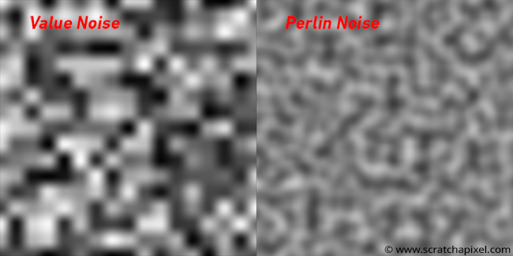
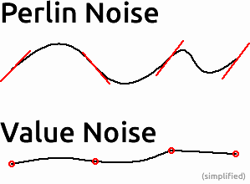
Perlin Noise, initially, was used to create procedural textures for computer-generated effects for movies (etc) (Perlin, 1985). But after the algorithm had garner more attention, it was then started to be used to generate various effects with natural qualities, such as clouds, landscapes and patterned textures like marble (Perlin, 1985)

Figure 1: Images comparing Perlin and Value Noise across a 1D and 2D plane respectively.

2.1 Fractal Noise - Introduction
Although Perlin Noise can generate smooth, more natural noise values across multiple dimensions; various Perlin Noise values can be generated, and then layered, to create more complex noise maps (Montana State University, 2005). This is known as Fractal Noise. To generate fractal noise, you can iterate through layers (or octaves) of noise values, that each have different lacunarity and persistence values, and then combine them. Lacunarity is “The rate as which successive octaves of the noise function increase in frequency” (Developer.Apple, n.d.), and persistence is “The rate at which successive octaves of the noise function decrease in amplitude” (Developer.Apple, n.d.). The Octaves, Lacunarity and Persistence together determine the frequencies of successive octave change, the frequency is “A value that determines the size and spacing of features in generated noise” (Developer.Apple, n.d.)
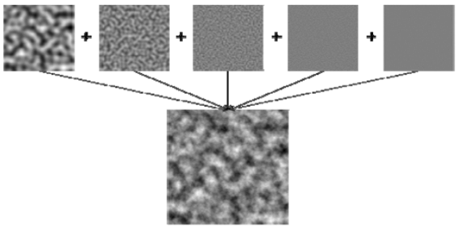

Figure 2: An example image showing different Perlin Noise maps being layered to create a Fractal Noise map.
Fractal Noise is extremely common within game development, as it is can be used to procedurally generate new terrains, with unique features, using just a single algorithm. Fractal Noise has been used many popular games. Minecraft, which has just surpassed 300 million copies sold this year (Austin, 2023) relies on Fractal Noise to generate their worlds (Kniberg, 2022).
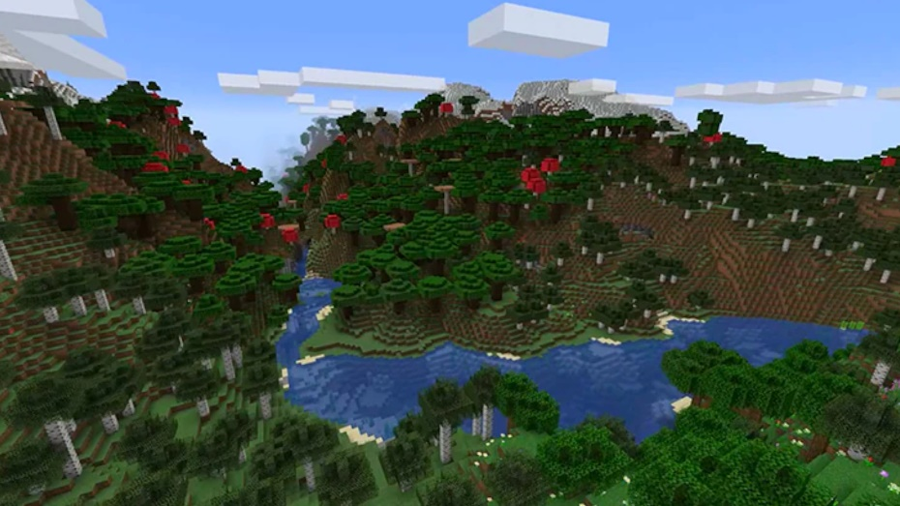

Figure 3: An example area within Minecraft showing procedurally generated terrain.

2.2 Henrik Kniberg – Terrain Generation
Using Minecraft as an example, Henrik Kniberg worked for Mojang from February 2018, until May 2022 (Kniberg, n.d.). During this time, he worked on Minecraft - focusing more on the procedural generation side of the game (Kniberg, n.d.).
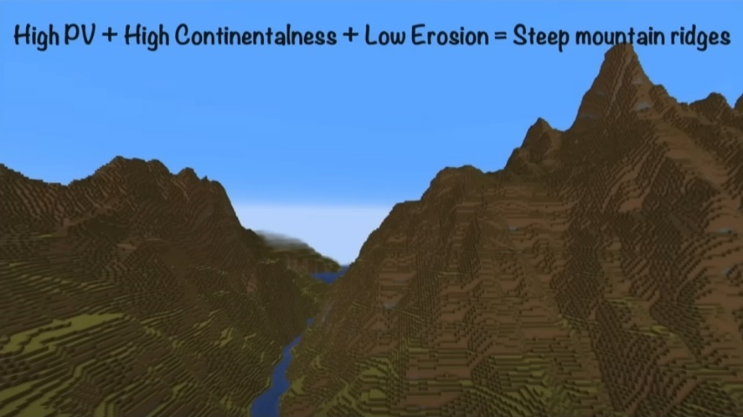
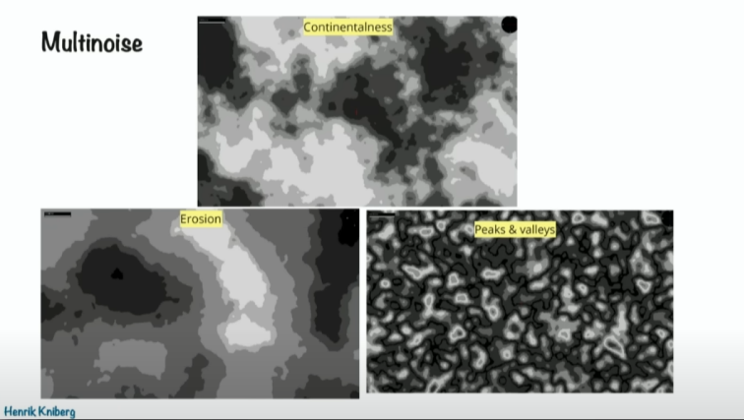
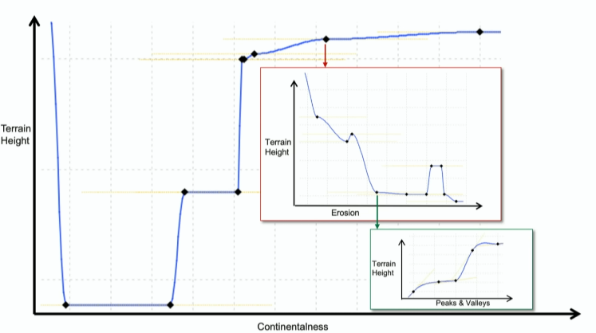
Henrik gave a talk in which he spoke about how they handled procedural generation in Minecraft at the time. In the talk, Kniberg explained that they would take multiple noise values (Continentalness, Erosion and Peak & Valleys, as he called them) and would then use splines using these values to determine which biomes would be generated at the point in the world, and the terrain height at that point (Kniberg, 2022).

Figure 4: Slides from Henrik Kniberg's talk, showing the usage of noise.

3.0 Perlin Noise - Implementation

3.1 Fractal Noise
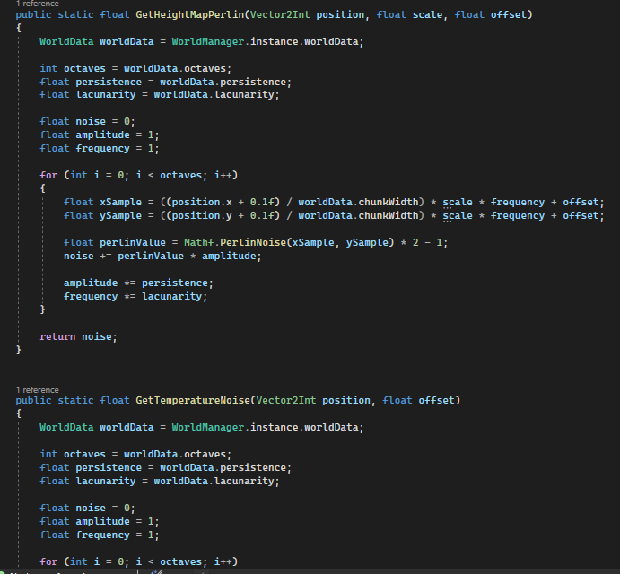
When using Perlin’s algorithm to generate Fractal Noise, with the goal of simulating biome diversity, it is important to implement multiple noise maps, each with their own offsets (to avoid repeating values) to create biome diversity. These noise maps were used to determine the height at which the biome was, and the temperature of the climate in that region. These values together were then used to generate the desired biome at the position in the world.
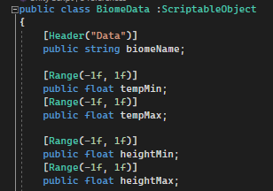

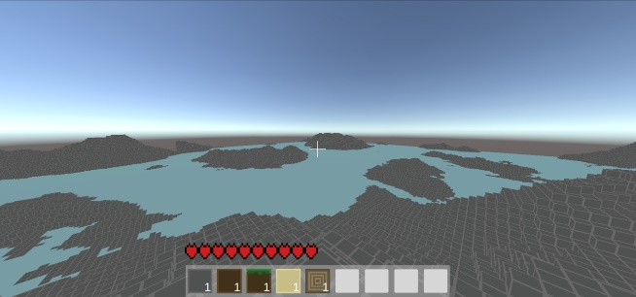
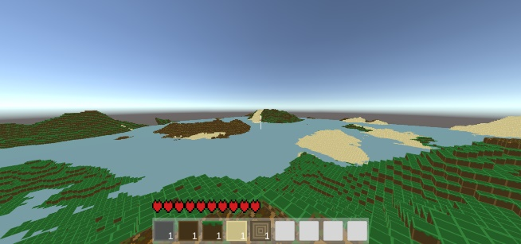
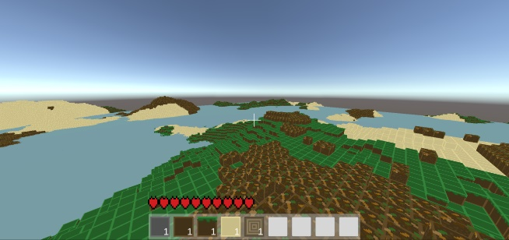
Figure 5: Code showing HeightMap and Temperature noise generation, as well as part of the biome class.
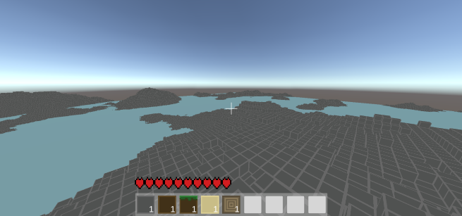
Figure 6: Screenshots from my project comparing the word generation with and without biomes.

3.2 Foliage Generation
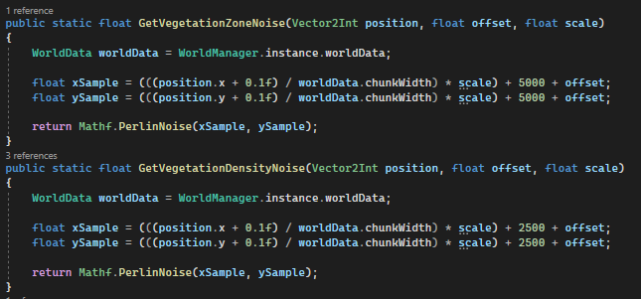
As well as using Perlin Noise for biome generation, the Author also used noise to generate foliage in the world. To do this, two separate noise values were used. The first value was used to determine a zone in which vegetation could be generated.
Figure 7: Code showing the GetVegetationZoneNoise() function.
If the method, shown in figure 7, returned a value that was greater than the zone threshold set on the biome, then the second noise value would be generated. This value was used to determine whether a plant should be generated at that point.

Figure 8: Code showing the GetVegetationDensityNoise() function.
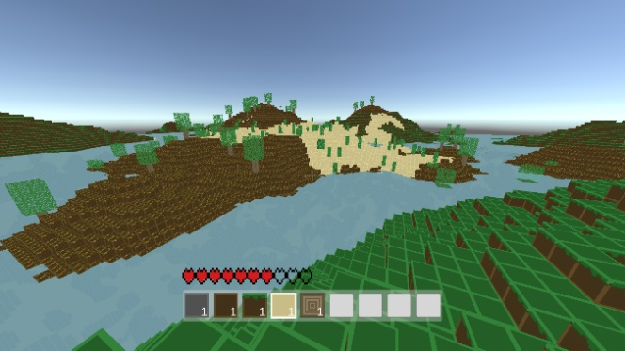
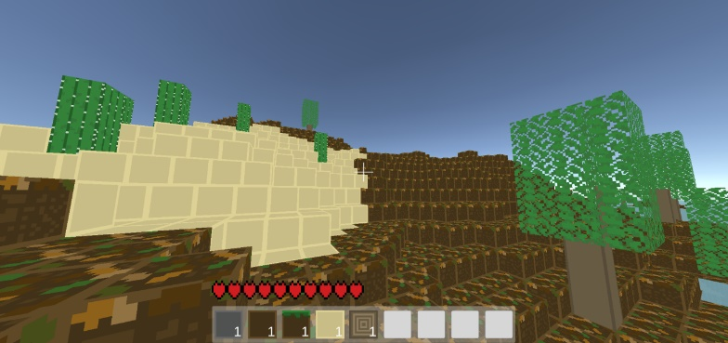
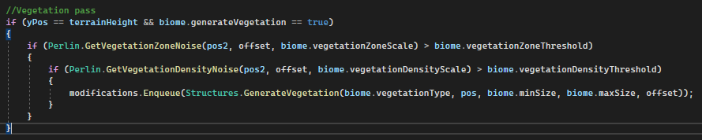
Again, if this value returned was greater than the respective threshold set on the biome, a plant would then be generated. It was important to add an additional offset to each calculation (5000, and 2500) just to ensure that the Perlin sample was being taken from different points. Furthermore, Unity’s Random.Range function could not be used, as it would conflict with the threading in the project (which will be discussed later in this report).
Figure 9: Code showing how I generate vegetation, and screenshots showing the outcome of the code.

3.3 Cave Generation
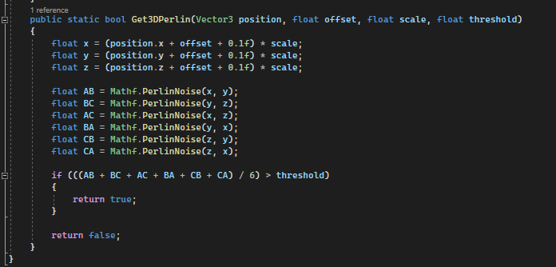
After a diverse terrain, populated with vegetation had been generated, the Author then had to add some caves underground. When researching methods to do this, it was determined that 3D Perlin Noise was the best fit at the time, as it was applicable to the current world generation methods because it only required one extra function.
Figure 10: My Get3DPerlin() function.
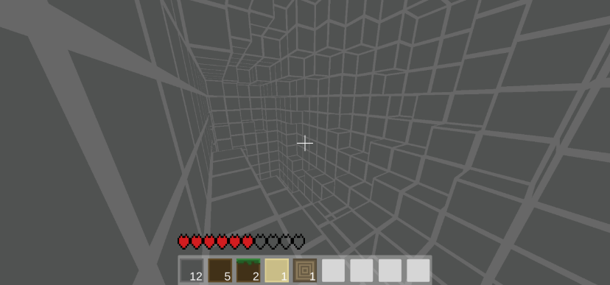
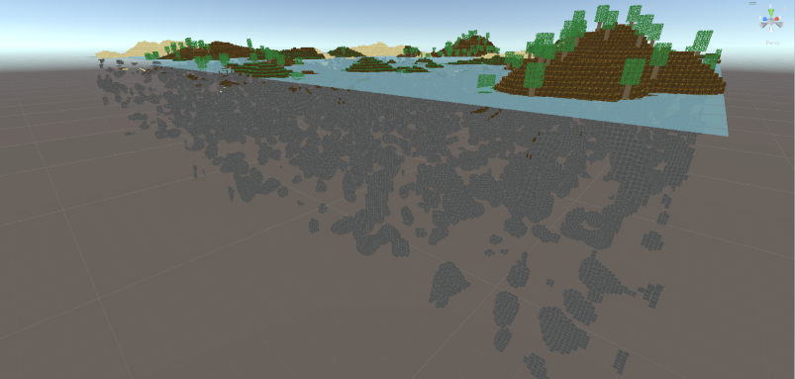
In this function, a noise value must be taken to represent each face of the voxel, making a total of 6 values, and then the average of those values would be the 3D noise sample. The resulting value must then be compared to the threshold parameter. If the value is greater than the threshold, the function returns true, meaning that the voxel at the requested position will be changed to air (forming a cave).
Figure 11: Images showing cave generation in my project.
As you can see in the example images above, the cave generation isn’t the best for producing natural looking cave systems. This is because 3D Perlin Noise only gives values at a specific location, and those values are not manipulated to determine a cave direction or scale.
To solve this, Perlin Worms could be used. Perlin Worms take a given position and then use a Perlin Noise value to smoothly direct the ‘worm’ in random directions. This provides a direction and the ability to hollow out the area around it; using different parameters like width, height and length, to form whole cave systems. (Eiserloh, 2018)

4.0 Multithreading
Loading chunks can be an intensive process for the CPU. To handle this, various methods can be explored to reduce the overhead. Multithreading CPUs was first conceptualised in during the 1950s, but the first instance of simultaneous multithreading was first used by IBM in 1968 (Nanos, 2023).
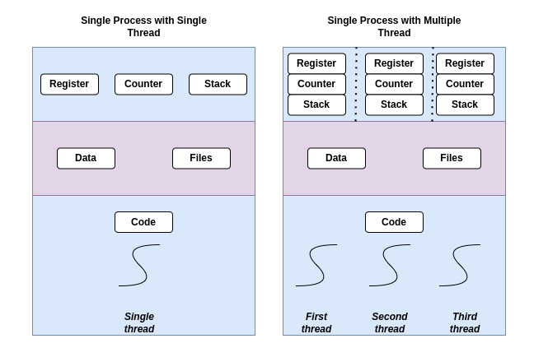

Figure 12: A diagram showing a process executed on a single thread, versus multithreading.

Within the games industry, multithreading has been used over the past few decades for various parts of game development (Vulkan, n.d.). Originally, multithreading was just used for more simple tasks, such as IO (Input/Output) and database calls; but as technology has advanced and games have gotten more advanced, teams now designate threads to large systems, such as: Rendering, Physics, Entity Component Systems, Update threads, and in some cases using threads for more complex AI, along with the main game thread that manages everything (Vulkan, n.d.).
Going back to technology, although the power of CPUs has been increasing every year; the performance of a single thread within CPUs has been stagnant (at a speed of 4-5ghz) for a while (Vulkan, n.d.). Meaning that most of the ever-increasing power we see from newer CPUs has come from the addition of more cores and threads. Because of this, the value of multithreading applications and games has increased dramatically within a relatively short period of time. (Vulkan, n.d.)

5.0 Multithreading - Implementation

5.1 Benefits of Multithreading
As mentioned in the introduction, the project started to suffer from significant FPS drops when exploring procedurally generated worlds. Even on a setup using an i7 12700k CPU and an RTX 3060ti. These FPS drops would be drops of 500+ fps, going from 500-550fps down to 3fps. This made the project almost unplayable, so a solution had to be found.

5.2 Dealing with Multithreading in Unity
The Unity Engine only opens a single thread to developers (quill18creates, 2017) who use their system and this can be worked around in two ways: the Unity Job System can be used, along with the Burst Compiler (Unity Documentation, 2023); or the chunk loading system could be reorganised to accommodate C# threading, which would mean that any UnityEngine features, such as MonoBehaviour objects and many math features (with some exceptions), would have to be removed from the threaded functions (quill18creates, 2017).

5.3 The Implementation
First, the Author had to separate chunk updating and chunk loading. In the project, ‘loading’ is the initial creation of the Chunk object (not to be confused with a Unity GameObject), and the generating of the Voxel data. “Updating” is whenever something interacts with the chunk and alters the data stored within it.
Doing this would mean that the player could load chunks, based on a customisable load distance, that would not yet be rendered. Which would further increase the speed of chunks appearing to the player. To do this, two new threads were created to handle these roles.
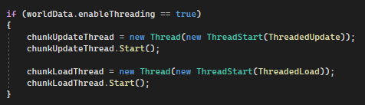

Figure 13: Image of code showing thread creation.
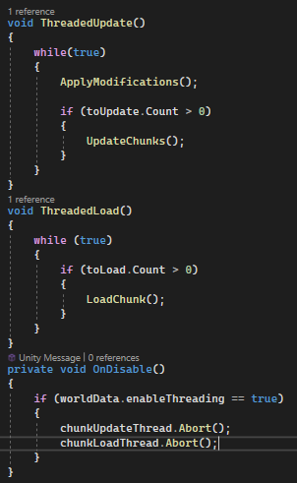
The Author chose to run the threads within an infinite while loop (so the threads did not need to be stopped/started multiple times).
Generally, this is considered a bad idea, especially for someone with no threading experience, as code getting stuck within an endless loop can put significant strain on the system (as it is constantly using the systems resources) and could potentially crash the program or system itself (Suhail, n.d.).
But the structuring of the functions meant that they each had their own responsibilities, that would not interact with the main game thread directly, and that the code within those functions would not get stuck; meaning that any unnecessary strain would not be due to the threaded functions.

Figure 14: Image of code showing thread usage.

Due to the reasons stated in section 5.1, the chunks mesh creation had to be separated from the data loading and updating, as the Mesh object in Unity is a part of the UnityEngine namespace. To deal with this, multiple “Task” lists were created that would individually handle the chunk loading, updating and drawing.
After the threading was implemented and everything was working, the project would rarely drop 100 frames when exploring the terrain (bottoming out at roughly 400fps instead of 3fps), even with twice the number of chunks being loaded.
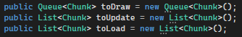

Figure 15: Image of code showing separation of chunk loading, updating and drawing.

6.0 Endless Terrain and RAM Management
A long with further improving the procedural generation methods, making the worlds endless (or as close to as possible, as even Minecraft has a world limit of 29,999,999 blocks (Minecraft Wiki, n.d.) ) would greatly improve the project. With the implementation of multithreading, this is now possible; but the next obstacle is handling the memory usage.
Currently, every chunk that is loaded by the player is not destroyed, the only thing that happens when a chunk is out of the player’s range is that it is set to inactive. Inactive objects in Unity, while the components added to them are disabled (Unity Documentation, n.d.), they still exist within the scene, and the references to all of their components are still stored in memory by Unity (Bonet, 2020).
To handle the stored references, the GameObjects could simply be destroyed instead of setting them to inactive. This would remove the references to the GameObject itself, and the Mesh component attached to them. References to mesh components are expensive, as the mesh component must store its Vertex Data, Texture Coordinates (or UVs), and its Index Data (Unity Documentation, 2023).
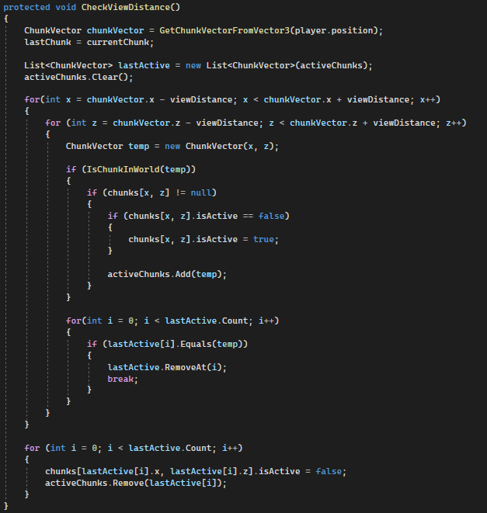
The issue with this is that the chunk would then lose any modified voxel data and would just be regenerated as if it hadn’t been changed at all. To deal with this, the voxel data of each chunk would have to be stored in an external, non-MonoBehaviour class, that can be called when reloading a chunk. This will mean that any chunks that are out of range can be destroyed, and then their respective data can be passed in if the chunk is reloaded.
Another bonus with this implementation is that it will allow the worlds to be saved and loaded, which will not only allow players to come back to their worlds; but will also make world generation quicker after the initial set-up.

Figure 16: Code showing current manage of out-of-range chunks.

7.0 Conclusion
To summarise, it is apparent that 3D terrain can be procedurally generated using algorithms such as Perlin Noise (Perlin, 1985), and then further develop that by layering Perlin Noise maps to create Fractal Noise (Montana State University, 2005).
However, if the Author was to push their project’s noise usage to the next level, they would have to consider more complex fractal noise algorithms, such as Fractional Brownian Motion or Fractional Gaussian Noise (Dider Delignieres, 2011), to generate more complex terrain. They could also implement different noise maps to add additional detail, such as an erosion noise layer to create more extreme terrains and more interesting biome diversity (Kniberg, 2022).
As well as an improve procedural generation system, the Author would also have to explore techniques to save and load chunks, as well as the world, to minimise memory usage. This would open the possibility of endless, or close to endless, world generation. Which would make the experience for the player seamless and much better.
Overall, working on this project was a great experience for the Author, and allowed them to explore techniques that they hadn’t experienced before.

References
Austin, S., 2023. MINECRAFT LIVE 2023: THE RECAP!. [Online]
Available at: https://www.minecraft.net/en-us/article/minecraft-live-2023--the-recap-
[Accessed 15 December 2023].
Bonet, R. T., 2020. Unity: How to Save Memory on Disabled GameObjects. [Online]
Available at: https://thegamedev.guru/unity-addressables/save-memory-ondisable/
[Accessed 15 December 2023].
Developer.Apple, n.d. Frequency. [Online]
Available at: https://developer.apple.com/documentation/gameplaykit/gkcoherentnoisesource/1823695-frequency
[Accessed 20 December 2023].
Developer.Apple, n.d. lacunarity. [Online]
Available at: https://developer.apple.com/documentation/gameplaykit/gkcoherentnoisesource/1778292-lacunarity
[Accessed 20 December 2023].
Developer.Apple, n.d. persistence. [Online]
Available at: https://developer.apple.com/documentation/gameplaykit/gkperlinnoisesource/1640299-persistence
[Accessed 20 December 2023].
Dider Delignieres, K. T. P. B., 2011. Transition from Persistent to Anti-Persistent Correlations in Postural Sway Indicates Velocity-Based Control. [Online]
Available at: https://www.researchgate.net/figure/Fractional-Gaussian-noise-and-fractional-Brownian-motion-Representation-of-the-continuum_fig1_50352315#:~:text=Fractal%20processes%20can%20be%20categorized,dependent%20variance%20(Figure%201).
[Accessed 14 December 2023].
Eiserloh, S., 2018. Math for Game Programmers: Digging with Perlin Worms. San Francisco, Game Developers Conference.
Kniberg, H., 2022. Reinventing Minecraft world generation by Henrik Kniberg. [Online]
Available at: https://www.youtube.com/watch?v=ob3VwY4JyzE&ab_channel=Jfokus
[Accessed 24 December 2023].
Kniberg, H., n.d. Henrik Kniberg - Experience. [Online]
Available at: https://www.linkedin.com/in/hkniberg/details/experience/
[Accessed 15 December 2023].
Minecraft Wiki, n.d. Henrik Kniberg. [Online]
Available at: https://minecraft.fandom.com/wiki/Henrik_Kniberg
[Accessed 14 December 2023].
Minecraft Wiki, n.d. World Boundary. [Online]
Available at: https://minecraft.fandom.com/wiki/World_boundary#Java_Edition
[Accessed 14 December 2023].
Montana State University, 2005. Perlin Noise Function. Bozeman(Montana): Montana State University.
Nanos, G., 2023. Multithreading vs. Hyperthreading. [Online]
Available at: https://www.baeldung.com/cs/multithreading-vs-hyperthreading#:~:text=The%20concept%20of%20multithreading%20CPUs,introduced%20by%20IBM%20in%201968.&text=Multithread%20programming%20allows%20the%20execution,support%20of%20the%20operation%20system.
[Accessed 14 December 2023].
Perlin, K., 1985. An Image Synthesizer. ACM SIGGRAPH Computer Graphics, 19(3), pp. 287-296.
Perlin, K., n.d. Chapter 4: In the beginning: The Pixel Stream Editor. [Online]
Available at: https://redirect.cs.umbc.edu/~olano/s2002c36/ch04.pdf
[Accessed 15 December 2023].
quill18creates, 2017. Tutorial: Unity & Multithreading. s.l.:YouTube.
Suhail, R., n.d. Unraveling the Infinite: Exploring the Mysteries and Perils of Infinite Loops. [Online]
Available at: https://medium.com/@rasiksuhail/unraveling-the-infinite-exploring-the-mysteries-and-perils-of-infinite-loops-327d7f46d858#:~:text=Infinite%20loops%20are%20a%20common,or%20even%20the%20entire%20system.
[Accessed 15 December 2023].
Unity Documentation, 2023. Job System. [Online]
Available at: https://docs.unity3d.com/Manual/JobSystem.html
[Accessed 15 December 2023].
Unity Documentation, 2023. Mesh data. [Online]
Available at: https://docs.unity3d.com/Manual/AnatomyofaMesh.html#:~:text=A%20mesh%20can%20contain%20up,surface%20at%20the%20vertex%20position.
[Accessed 15 December 2023].
Unity Documentation, n.d. GameObject.SetActive. [Online]
Available at: https://docs.unity3d.com/ScriptReference/GameObject.SetActive.html
[Accessed 14 December 2023].
Vulkan, n.d. https://vkguide.dev/docs/extra-chapter/multithreading/. [Online]
Available at: https://vkguide.dev/docs/extra-chapter/multithreading/
[Accessed 14 December 2023].

