A Reflection on The Development of Tidy Town

Author: Ben Higham
Date: 12/11/2024
Contents
Table of Figures 3
1.0 Introduction 4
2.0 About PAOW 4
2.1 Analysis and Evaluation of the Client’s Needs 4
2.2 Limiting Factors and Product Scope 6
2.2.1 Analysis and Evaluation of the Limitations and Scope 6
3.0 The Development Process 7
3.1 The Development Team 7
3.2 Agile 7
3.3 The Product Design and Genre 8
4.0 Reflection on The Project 8
4.1 Personal Contribution to The Project 8
4.2 AI Development Process 9
4.2.1 Introduction 9
4.2.2 Pathfinding 9
4.2.3 Waypoints 10
4.2.4 Sensors 12
4.2.5 Car AI 13
4.2.6 Customer AI 15
4.2.7 Pedestrian AI 16
4.3 Why Unity? 17
5.0 Conclusion 17
References 18

Table of Figures
Figure 1: Tidy Town Splash Screen 4
Figure 2: PAOW Logo 4
Figure 3: Chart showing Desktop vs Mobile RAM distribution (Garrard, 2018) 6
Figure 4: Unity Profiler 7
Figure 5: Agile Sprint Cycle (ProductPlan, n.d.) 8
Figure 6: Image Showing the Features of Unity's Navigation System (Johnston, 2018) 9
Figure 7: PathPlan Class 10
Figure 8: AI_Waypoint Class 10
Figure 9: AI_SwitchWaypoint class 10
Figure 10: AI_WaypointPath Class 11
Figure 11: ScanForTag and ScanForLocation functions in Location_Sensor 12
Figure 12: _isLeaving Logic in Agent_Car Class 13
Figure 13: Parking Logic in Agent_Car class 13
Figure 14: UpdateWaypoint Logic in Agent_Car 14
Figure 15: Image Showing Collision Sensors on the Car AI 14
Figure 16: Code Snippets Showing Customer AI Logic 15
Figure 17: Pedestrian Linger Logic Code Snippet 16
Figure 18: Unity Logo (Unity, n.d.) 17

1.0 Introduction
Throughout this module, the team was tasked to develop a fully functional game (Tidy Town) that met a client’s demands. Within this report, detail will be provided about the client (PAOW) and what their goals are. Any product requirements they listed, and some information about how the team handled those requirements, will then be covered. The report will then provide some insight into the development team itself, and how the development of the product was handled over the 8-week period. Finally, the author will go into detail about their personal contributions to the product.


Figure 1: Tidy Town Splash Screen

2.0 About PAOW

PAOW, which stands for ‘Pledge, Act, Observe and Win’, is “a collaborative project initiated by the University of Bolton and the former Bolton Students’ Union President (2021-23)”. The goal behind the initiative is to build partnerships with local communities with the intent to work together to keep the area clean (University of Bolton, n.d.).
PAOW has two main aims: The first is to encourage business owners to keep the area around their locations clean, and to also provide bins for their customers that they are encouraged to use.
The second aim is to get the University of Bolton to encourage their students to actively partake in cleaning up the local area. Be that through litter picking, campaigning, or by promoting and engaging with PAOW social media (University of Bolton, n.d.).
Figure 2: PAOW Logo

2.1 Analysis and Evaluation of the Client’s Needs
The client’s focus is on encouraging business owners to keep their businesses, and the surrounding areas, clean. They wanted a product, created in 8 weeks, that puts the user in the position of a business owner, with the clear message being pushed through that keeping an area clear of litter is beneficial, so the user will have to be rewarded for achieving this aim. As students at the University of Bolton, it is also the team’s responsibility to, not only provide a functional product that portrays this message, but also to make the user aware of PAOW.
As the client’s pitch was centred around a litter-picking game, they also put emphasis on wanting the user to have to manage their litter responsibly, meaning that the user would have to sort their litter into the correct bins (recycling, general waste, food waste, etc). To add to this, the client also pitched that the user would have to be safe when gathering up the litter by using the correct equipment.
After listening to the pitch, the team decided that these ideas were critical to push the message that the client wanted. Having the user sort litter into the correct bins not only puts emphasis on keeping the local area tidy and protecting the environment through proper recycling and waste management, but it also added an element of skill when adapted to fit within a game scenario (making the game more fun). The second idea they pitched was that the user would have to use the correct equipment to pick up specific types of litter. This is a great idea that would add further skill to the game and promote safety, but because the game was pitched to be a mobile game; the team thought that that having to cycle between different tools would clutter up the UI on such a small screen. To work around this, the team thought it was better to model the player’s character with the necessary equipment needed to safely gather litter. This visualisation of the correct equipment portrays safety in the same way, without having a direct impact on the gameplay itself.
The team also thought that the implementation of varied AI agents was critical for the final product. This is because the game is set in a local town setting and having AI to represent pedestrians walking around the town; customers interacting with the player’s business; and cars driving around the roads, brought a natural and immersive atmosphere to the game.

2.2 Limiting Factors and Product Scope
As mentioned previously, the client intended for the game to be created for mobile devices. While the long-term development of a game for mobile platforms has a low barrier of entry, due to significantly lower costs of development and marketing (Claudio Feijoo, 2012), mobile devices ( in general) have significant hardware limitations compared to desktop PCs and consoles, especially compatibility issues with graphics features (Epic Games, n.d.). A main difference between mobile and desktop performance is that RAM (Random Access Memory) is shared between the GPU (Graphics Processing Unit) and CPU (Central Processing Unit) in most mobile models, whereas GPUs and CPUs have their own RAM in desktop PCs and consoles. This setup saves more power for the mobile devices but can also bottleneck performance if there are any GPU or CPU intensive process executions (Garrard, 2018).
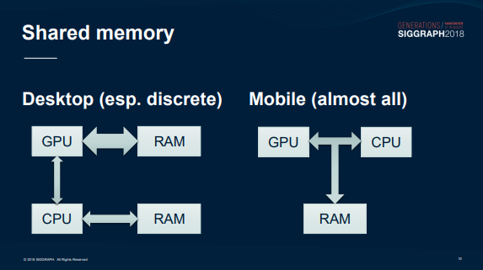

Figure 3: Chart showing Desktop vs Mobile RAM distribution (Garrard, 2018)
The user’s ability to interact with the game was also considered by the team. While touchscreen controls have become far more precise with modern mobile models, touchscreen input still cannot provide the precision offered by other input methods on console and PC. This makes the development of any fast paced or complex mechanics difficult (Dobrozorova, 2023).
Finally, because the product was to be delivered at the end of an 8-week period, the product scope had to be managed carefully to ensure that any features were implemented fully with minimal (or no) bugs.

2.2.1 Analysis and Evaluation of the Limitations and Scope
Mobiles typically don’t provide the hardware necessary for high-end graphics seen in most modern console and PC games. The team took this into account when creating assets and handling any post-processing features for the product by making simpler models and utilising lower quality graphics features. A benefit with this approach, however; is that the team was able to produce new assets at a faster rate, which improved the quality of the product due to the turnover time.
The same solution was applied to the hardware limitation of shared RAM between the GPU and CPU in most mobile models (Garrard, 2018). Having simple, low-poly assets, and using lower-quality rendering features will reduce stress on the GPU, reducing the amount of RAM needed at any time. Beyond graphical solutions, the programmers also had to ensure that any code implemented was not only functional, but also optimised. As the product was developed in Unity, using the Unity Profiler, which “is a tool you can use to get performance information about your application” (Unity, n.d.), allowed the programmers to see any functions that hindered performance.
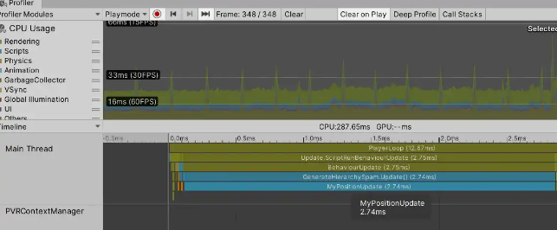

Figure 4: Unity Profiler

3.0 The Development Process
After first receiving the clients pitch, the team separated into three groups and spent the first week creating three different prototypes. Each prototype was then pitched to the client in the second week before a final product was decided on. During the third week, the team roles were decided, and development was started.

3.1 The Development Team
The team behind Tidy Town consists of 12 developers from all three branches of game development (Programming, Art and Design).
The basic structure of the team was this: There was one project leader who managed the development process as a whole and monitored each person’s contributions via a weekly scrum meeting. There was a lead for each discipline, a Lead Programmer, a Lead Designer, and a Lead Artist. The three leads, along with the project leader, kept in contact with one another and updated each other on the progress of everyone in the team. Finally, each member would take tasks listed in a backlog to work through them. They would then update the backlog, and their respective leader, when a task was ready for testing.

3.2 Agile
To aid with organising the team, the project lead chose to implement the Agile Methodology. “The Agile methodology is a project management approach that involves breaking the project into phases and emphasizes continuous collaboration and improvement. Teams follow a cycle of planning, executing, and evaluating” (Atlassian, n.d.).
Each week of development was split into its own Sprint, which is a short development cycle that consists of: Planning, implementing the plan, testing the implementation, and then reviewing the sprint during the next Scrum meeting. During each Scrum meeting, each member in the team explained what they had done during that sprint, talk about any issues they had, and then suggest what they could do over the next sprint. After each member had spoken, the project leader updated the backlog with the next tasks.
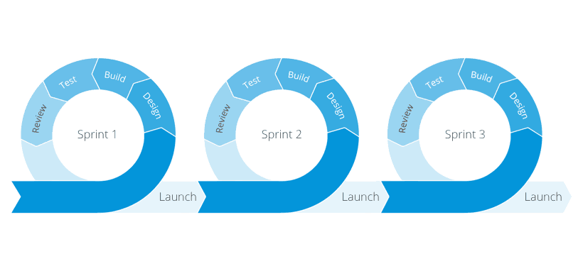

Figure 5: Agile Sprint Cycle (ProductPlan, n.d.)
This system benefited the team greatly, as each member knew what everyone was working on, and everyone was getting consistent feedback on their work because of the frequent testing.

3.3 The Product Design and Genre
Due to the limitations previously mentioned, the product had to be kept simple. Because of this, the genre decided was a 3d top-down collect-a-thon game, where the player moves around a setting, based on a local supermarket within a town, gathering litter. The player would then take the litter back to the shop bins and organise litter into the correct bins to gain points (or lose points if the bin was wrong).
Having completed the project, the genre decided for the product was a great choice for providing a game that would fulfil the client’s requirements. A collect-a-thon game is perfect for a game where collecting litter is the focus as the genre is defined by the player exploring “in order to collect elements or pieces of various objects” (Cassone, 2019).

4.0 Reflection on The Project
Overall, I think the development of the product went well, especially considering the size of the team. As a studio, we achieved a functional product that fulfilled the client’s requirements, but due to the lack of experience across all members, there were some organisational issues early on in development that slowed things down.

4.1 Personal Contribution to The Project
As I worked on the prototype chosen at the start of development, I was first tasked with the initial setup of the project, which entailed me reimplementing the prototype logic in a more scalable and development-friendly manner. Once this was done, and the designers were happy with their first iteration of the GDD (Game Design Document), my focus was on the AI in the game. I worked on developing the AI for all NPCs in the game, which include the Customers (NPCs with trolleys that travel to and from the supermarket via their respective cars), the Pedestrians (NPCs that traverse the outside town), and the Cars (NPCs that travel around the outer roads, some of which enter the carpark to find a parking space).
I was tasked with AI development, as the initial AI concepts were mine when developing the prototype, and because I had the most experience in working with AI among the programmers.
The AI is an important element in Tidy Town as it brings together the town-like atmosphere that the team was aiming for, and “AI is responsible for drawing the player into the game environment” (Jeremy A. Glasser, 2004). The AI is also what generates new litter that the player must collect, as well as contributing to multiple fail-conditions that the player must avoid. Due to its importance, and the complexity of getting the cars to function like real life (stopping at traffic lights, parking, avoiding collisions with one another), the AI took up the bulk of development.
When working on the AI, I had to learn how to use Unity’s Navigation system because I hadn’t used it before. It was also my first time developing AI for cars, and managing the collision through custom sensors (as Unity’s avoidance system did not function how I wanted for the game) was a difficult, but enjoyable, learning curve.
As well as AI development, I handled some of the initial gameplay implementations (such as litter and litter spawning, as well as power up logic) and some general optimisation. When optimising other programmers’ code, I had to communicate with them to ensure they understood any changes, and to also make sure that I fully understood what they intended if it was vague in the code. This was something I had not done before as I have been the sole programmer in previous team projects.

4.2 AI Development Process

4.2.1 Introduction
My main commitment to the project was developing the AI and the relevant systems necessary for its functionality. I will briefly talk about the components used to develop the AI, any specific rationale behind the decisions I have made, and how it all links together to work in the product.

4.2.2 Pathfinding
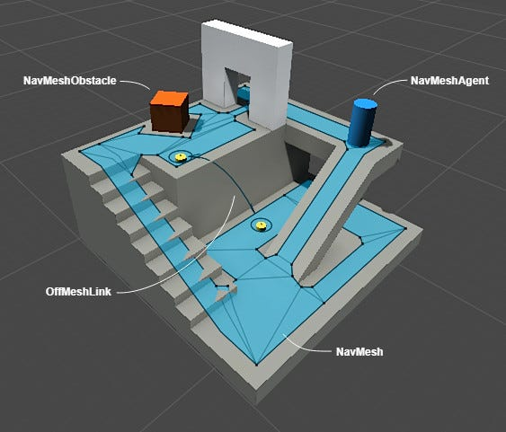
Pathfinding is a fundamental part of AI agents, its what allows an agent to navigate the world they are placed into. Due to the scope of the project, I decided against developing my own pathfinding system to save time and to have access to a higher-level navigation system from the start of development. As the team had decided to develop the game using Unity, I chose to go with Unity’s built-in Navigation system for my AI.

Figure 6: Image Showing the Features of Unity's Navigation System (Johnston, 2018)

4.2.3 Waypoints
To give AI agents targets to navigate towards when traversing Unity’s NavMesh (Navigation Mesh), I created a basic waypoint system. The system comprises of three elements:
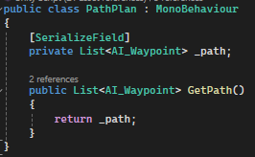
The first is a PathPlan. A PathPlan is a very simple data container that is placed into the scene and contains a List<> of AI_Waypoints that are added by the developer when setting up the scene.

Figure 7: PathPlan Class
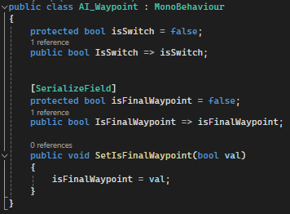
The second are the AI_Waypoint and AI_SwitchWaypoint. Both are almost identical, they are added to the scene and passed into the PathPlan as mentioned above. Both types of waypoints can be flagged as the final waypoint (_isFinalWaypoint), meaning they are the final waypoint in that specified path.

Figure 8: AI_Waypoint Class
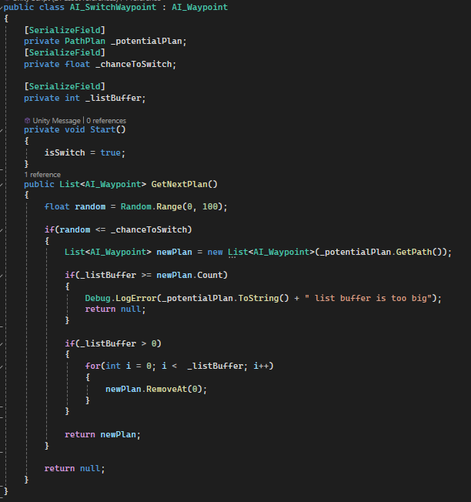
What differentiated the AI_SwitchWaypoint is that they represent a waypoint that can potentially change the agent’s path to a different PathPlan. This is important for the Car Agents as they have a random chance to enter the carpark or carry on around the surrounding road.

Figure 9: AI_SwitchWaypoint class
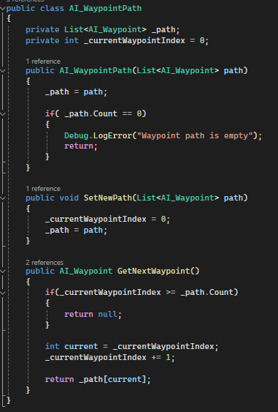
The final element is the AI_WaypointPath. This class is attached to each agent that uses the Waypoint system, and simply just creates a copy of the List<> set in PathPlan. The agent can then query their AI_WaypointPath to determine the next waypoint in their path.

Figure 10: AI_WaypointPath Class

4.2.4 Sensors
To aid my AI agents with their behaviour, I had decided to make my own custom Sensors.
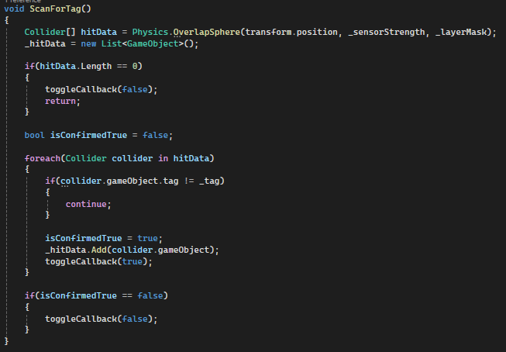
The first type of sensor I made was a Location_Sensor.
A Location_Sensor is not direction specific, and one option for the Location_Sensor is to scan for a specified object Tag within a set radius around the agent it is attached to (Tags act as references that can be assigned to GameObjects. “Tags help you identify GameObjects for scripting purposes” (Unity, n.d.)).
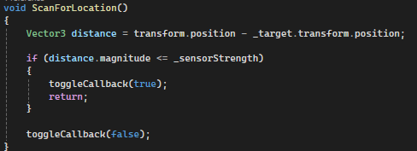
But, if the developer would want to get the distance between the agent and a specific GameObject, they could also Initiate the Location_Sensor with the position of the GameObject, and the _sensorStrength will be used to trigger the passed in bool function if the distance between the agent and the object is within the specified radius.

Figure 11: ScanForTag and ScanForLocation functions in Location_Sensor

The second sensor type I created was the Direction_Sensor. This would use a specified direction to perform a targeted Raycast physics check, instead of using a general check of the radius around the agent. This was necessary for the Car AI as I did not need the cars to know about what was behind them, aside from when reversing out of a parking space, because the cars behind them would determine if a collision would occur. Outside of the direction, the logic is the same as the Location_Sensor.

4.2.5 Car AI
Although the Car AI was the most complex overall, the core behaviour logic was simple. The car agent would work through a basic behaviour tree to decide what to do next:
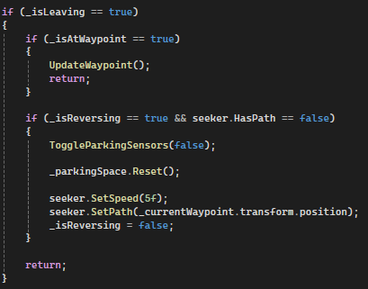
First the agent would check if it was leaving, meaning it would check if it had entered a parking space, and its spawned customer had returned. If it was leaving, the car would reverse out of the parking space before pathing to the next waypoints.

Figure 12: _isLeaving Logic in Agent_Car Class
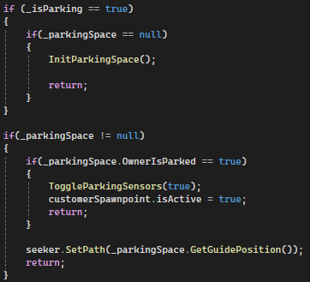
If the agent isn’t flagged as “_isLeaving”, the agent will check if it’s parking sensor has detected an available parking space in its path. If this is the case, the agent will be flagged as “_isParking” and the found parking space will be Initiated, meaning the parking space would become aware of the car and vice versa. The parking space would then use a guide, that the player does not see, that the car agent will seek (follow) until it has successfully parked. Once parked, the customer spawn point attached to the car will become active, allowing a customer to be spawned. This method of parking was preferable to the alternative, which involved using Machine Learning (which “is the scientific study of algorithms and statistical models that computer systems use to perform a specific task without being explicitly programmed.” (Mahesh, 2020) ).to have the cars learn how to park themselves, as this method would require far more time than available.

Figure 13: Parking Logic in Agent_Car class

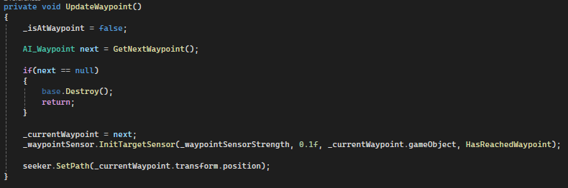
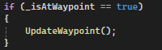
If both flags are false, then the agent traverses between waypoints until their path ends.
Figure 14: UpdateWaypoint Logic in Agent_Car

To prevent cars from crashing into each other, and to make the cars aware of traffic lights, parking spaces, and other objects in front of them; each car agent had 7 direction sensors attached to them. 5 on the front (two of them being angled slightly to aid collision detection when turning) and two on the back (which are only active when the car is reversing out of a parking space). These sensors together give the car agent all the information it needs to know to determine its next behaviour, and if it should stop pathing to avoid any collision.
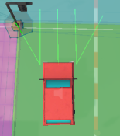
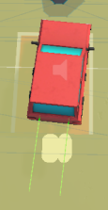

Figure 15: Image Showing Collision Sensors on the Car AI

4.2.6 Customer AI
The AI for the customer agents was the simplest to implement, as they simply had to just move from the car they spawned at to the supermarket, and then from the supermarket back to their car after a brief delay.
There was no real structure to this AI, as the agent only had to check if it was inside of the shop or not, because the pathing calls were handled when spawned (the destination would be set to the supermarket entrance) and when exiting the shop (destination set back to the car/spawn point). To determine whether the agent was entering the shop, a Location_Sensor was attached to the agent that would scan for the “Store Entrance” tag when pathing to the entrance. When exiting, the same sensor would then scan for the spawn point GameObject that they were spawned at.
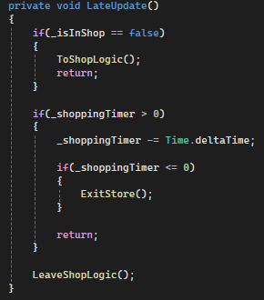
When spawned, and when pathing between locations, the agent would drop a piece of litter at a set interval.
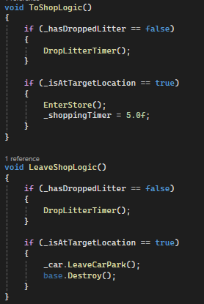
Figure 16: Code Snippets Showing Customer AI Logic

4.2.7 Pedestrian AI
Like cars, I used a combination of a simple behaviour tree and sensors to handle the Pedestrian agent behaviour. In the product, pedestrians had no real goal to achieve unlike the other AI. They wander around the streets surrounding the supermarket until they randomly reach a waypoint that is flagged as _isFinalWaypoint (refer to 4.2.3 for context). Unlike cars, the waypoints the pedestrians use are not stored in a PathPlan, I decided to change this as I felt that the pedestrian pathing being random felt more natural as opposed to cars that must follow the roads. Instead, I added an extra function to the Location_Sensor that would, like the original, do a general check around the agent and detect any AI_Waypoints close to them. However, to add a directional bias, I added an extra check that would utilise the Dot product between the agents forward vector (the direction the agent is facing) and the position of a found waypoint. Using the Dot product, I could determine if a waypoint was in front of the agent, and then add it to a new List<> that would be returned to the agent. Using this new list, the pedestrian agent could choose a new waypoint, at random, that was in front of them.
As well as the random pathing, pedestrians would also have to stop at the crossings placed around the map if the traffic lights were green (meaning cars were actively moving through the crossing). This created further realism as people walking out into traffic isn’t typical behaviour.
The final aspect of the pedestrian AI was the lingering mechanic. To add a behaviour that would lead to the pedestrian dropping litter (the core element of the product), I added a sensor that would search for any GameObjects tagged as a “Street Corner”, if the pedestrian agent stopped with one of these objects in range, they would linger for a set amount of time before moving on. At the end of each linger period, the agent would drop a piece of litter.
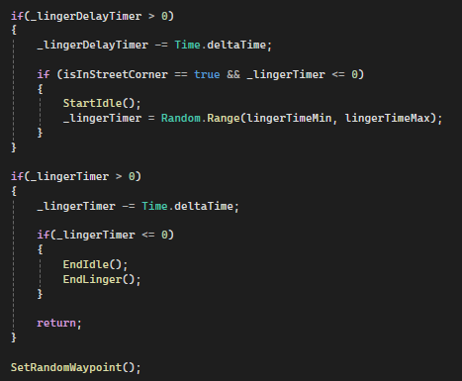

Figure 17: Pedestrian Linger Logic Code Snippet

4.3 Why Unity?
As a programmer, the game engine used when creating a product is an important factor to consider. When pitching the initial prototype, I pushed for Unity to be the chosen game engine for this project. The main reason being is that Unity is at the forefront of mobile game development, and over 70% of the top mobile games currently available are developed using Unity (Unity, n.d.).


Figure 18: Unity Logo (Unity, n.d.)

5.0 Conclusion
In conclusion, the team was successful in providing a functional game that fit all PAOW’s (the client) requirements and within the specified timeframe. The game highlights PAOW’s aim of promoting litter picking in a local setting by encouraging a local business owner (the player) to clean up the area around them. Furthermore, it also utilises students from the University of Bolton (who make up the development team) to help spread the message through social media (in-game social media links) and other means (the game itself).
Personally, the whole experience has been an enjoyable and challenging learning experience, and I am overall proud of the product developed, despite some minor development issues, and have gained some insight into how working within a larger team can function.

References
Atlassian. (n.d.). The Agile Coach. Retrieved from Atlassian: https://www.atlassian.com/agile#:~:text=What%20is%20the%20Agile%20methodology,READ%20ON%20BELOW
Cassone, V. I. (2019). Towards a Trading zone. A semiotic method for crossdisciplinary case study analysis of gamified systems. (pp. 70-83). Kittilä: GamiFIN.
Claudio Feijoo, J.-L. G.-B.-M. (2012). Mobile gaming: Industry challenges and policy implications. Telecommunications Policy, 212-221.
Dobrozorova, T. (2023, October 10). Mobile Games vs. Console Games: A Detailed Guide. Retrieved from Hitberry Games: https://www.hitberrygames.com/post/mobile-games-vs-console-games-a-detailed-guide
Epic Games. (n.d.). Mobile Rendering Features. Retrieved from Unreal Engine: https://dev.epicgames.com/documentation/en-us/unreal-engine/rendering-features-for-mobile-games-in-unreal-engine?application_version=5.4
Garrard, A. (2018). Moving Mobile Graphics: Mobile Graphics 101. SIGGRAPH. Vancouver: SIGGRAPH.
Jeremy A. Glasser, L.-K. S. (2004). AI in Computer Games: F AI in Computer Games: From the Pla om the Player’s Goal t s Goal to AI’s Role . Lincoln: University of Nebraska.
Johnston, D. (2018, April 11). Build VR: Using Unity NavMesh for First Person Movement in VR. Retrieved from Medium: https://medium.com/@davijoh73/build-vr-using-unity-navmesh-for-first-person-movement-in-vr-64efe0909d84
Mahesh, B. (2020). Machine Learning Algorithms - A Review. International Journal of Science and Research, 381-386.
ProductPlan. (n.d.). Sprint. Retrieved from ProductPlan: https://www.productplan.com/glossary/sprint/
Unity. (n.d.). Guidelines for Using Unity Trademarks. Retrieved from Unity: https://unity.com/legal/branding-trademarks
Unity. (n.d.). Tags. Retrieved from Unity Documentation: https://docs.unity3d.com/Manual/Tags.html
Unity. (n.d.). Unity for mobile game development. Retrieved from Unity: https://unity.com/solutions/mobile
Unity. (n.d.). Unity Profiler. Retrieved from Unity Documentation: https://docs.unity3d.com/Manual/Profiler.html
University of Bolton. (n.d.). What is PAOW? Retrieved from https://www.bolton.ac.uk/student-area/paow

