My Goal
Working on Fruit Frenzy was my first experience with working within a team environment, with people from various roles. Because of this, and the fact that I was late to join the group, my main goal was to make sure that everything that was asked of me was completed on time; and to make all my classes simple to understand, with exposed variables and functions that the level designers could access when needed.
Wave Handler Class
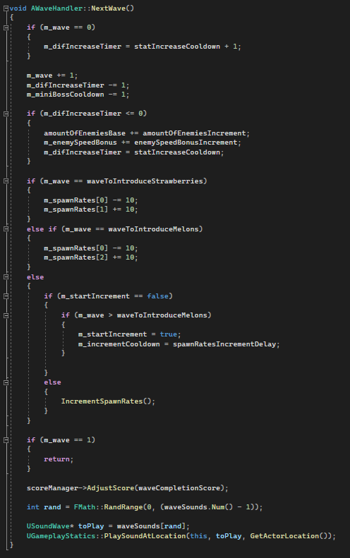
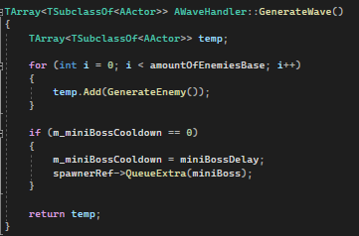
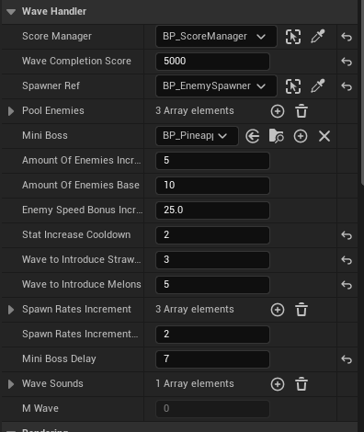
Some screenshots showing the core functionality of the WaveHandler class, as well as the inspector view.

Spawnpoint Class
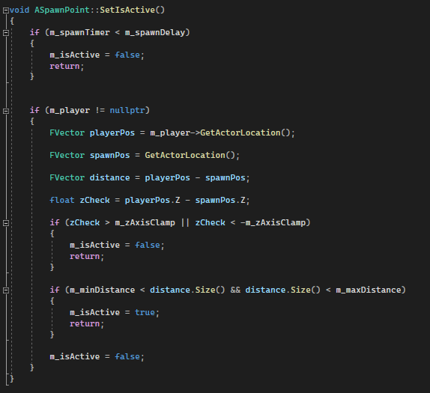
Spawnpoint to player distance check, as we did not want enemies spawning too far away from, or close to, the player.

Enemy Spawner Class
Code showing the initialisation of Spawnpoints within the Enemy Spawner class, and the inspector view.
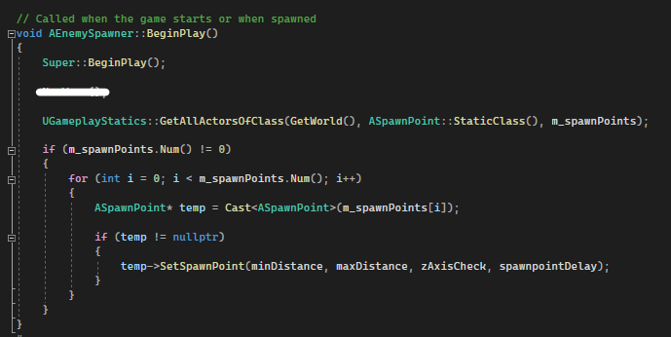

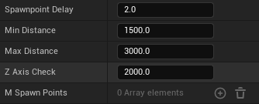

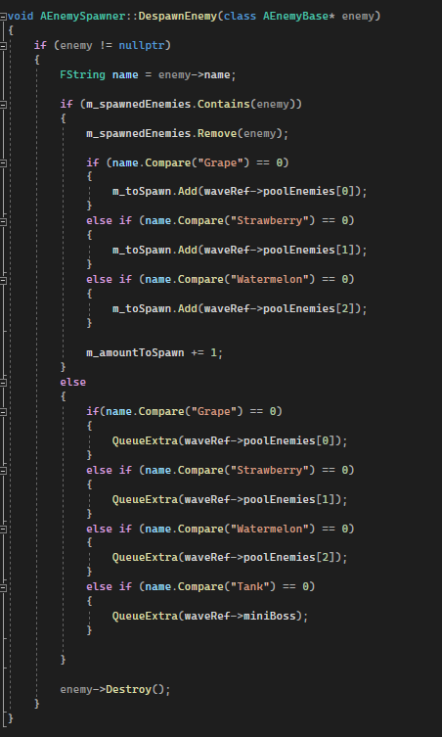
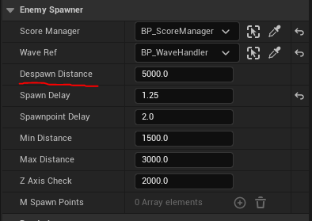
Despawning that checks the enemy type; and if it was a part of the regularly spawned waves, or a random event/boss. This logic means that a respawned enemy will always be of the same type that was despawned. The despawn distance is applied to the enemy when spawning it, and can be changed in the inspector panel.

Hardpoint Class
The Tick() function logic, this checks whether the hardpoint if unlocked (in an unlocked area), and started (checks if the player has started the hardpoint). If both checks are fulfilled, the hardpoint will then check if the player is within it. If true, the timer will increment, else the timer will decrement.
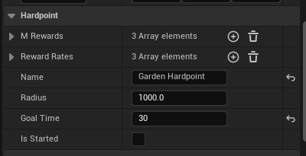
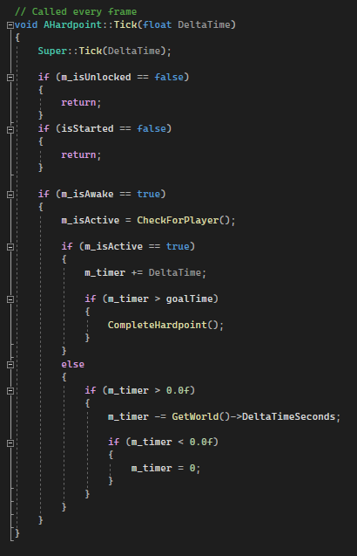
If the timer reaches the goal time, the hardpoint will complete.

Hardpoint Manager Class
The inspector view, showing exposed variables.
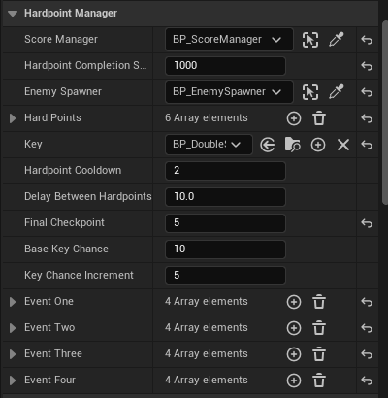

Logic showing the starting of a new hardpoint. The first hardpoints could be set as checkpoints, meaning that the earlier hardpoints would always follow the same order. When the checkpoints were complete, new hardpoints would be randomly chosen (hardpoints would have individual cooldowns to prevent repetition).
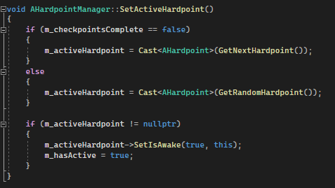
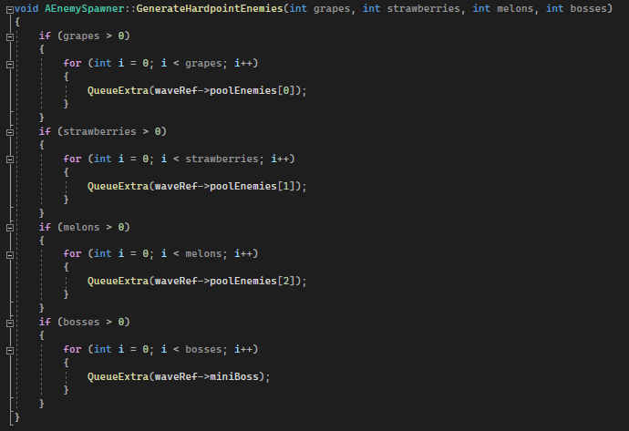
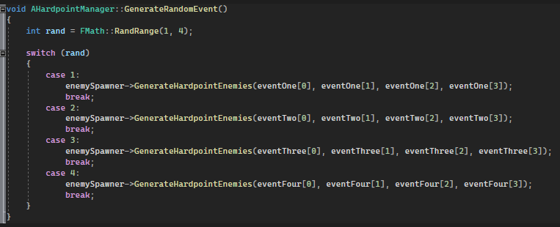
When the active hardpoint is then started by the play er, a random event is started.

Area Manager Class
To handle which Spawnpoints and Hardpoints were active, I created an Area Manager class, which is essentially just a container to handle the state of Spawnpoints and Hardpoints within them. The function SetIsUnlocked(bool check) is blueprint accessible, this could be called from gates, when they were being opened, to unlock the new area.
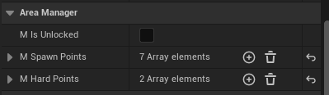

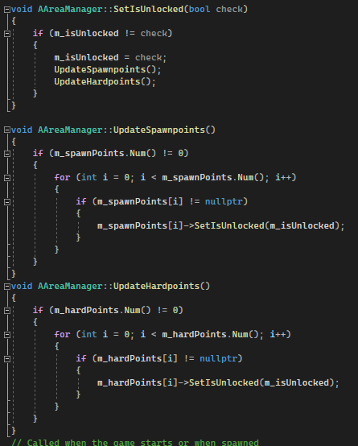

Enemy Class
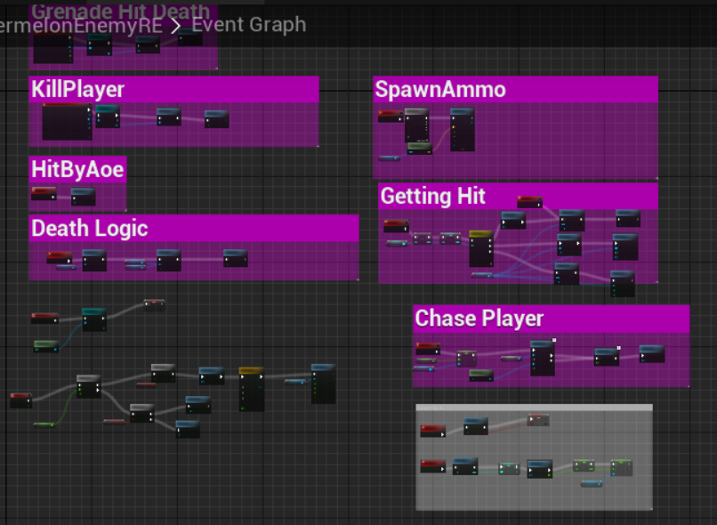
When first joining the group, each enemy type had the same blueprint logic (instead of just being derived from a parent enemy class), which meant that any changes to the function logic had to be repeated on each enemy.

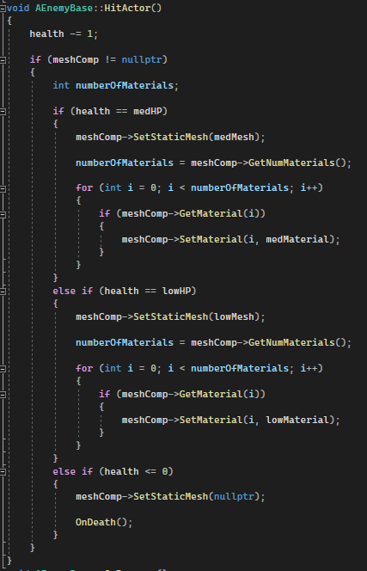
Once the first iteration of the tasks I had been set was complete, the first thing I did was create a base enemy class that would take repeated logic from the blueprints, and then re-create the blueprints using the enemy base class as a parent.

The HitActor() function removes one health from the enemy, and then checks if a new mesh and material should be loaded (to show a damaged state)

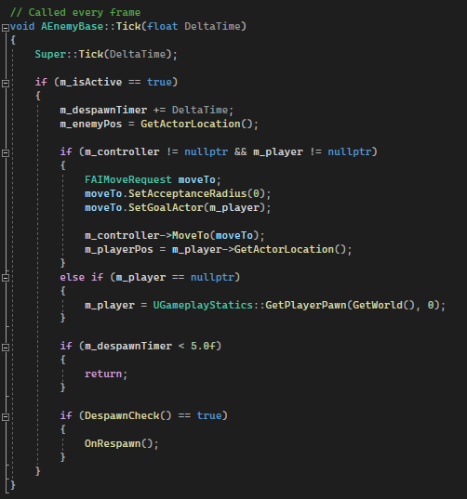
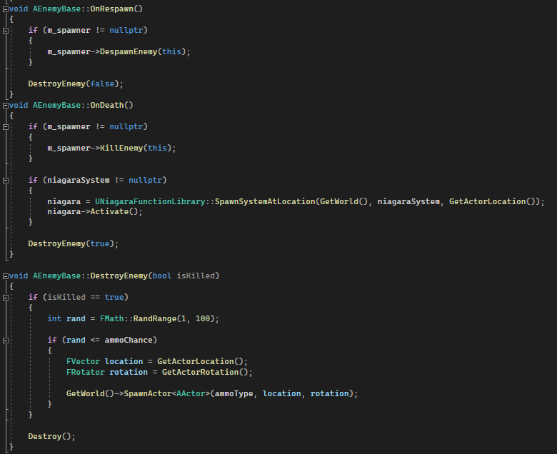
Functions to respawn or kill the enemy. If the enemy is killed, a Niagara system is activated, and a sound is played. The DestroyEnemy() function takes a bool parameter that checks if the enemy has been killed, which will trigger a random chance to spawn an ammo drop.

Logic that handles player seeking and enemy despawning is within the Tick() function.

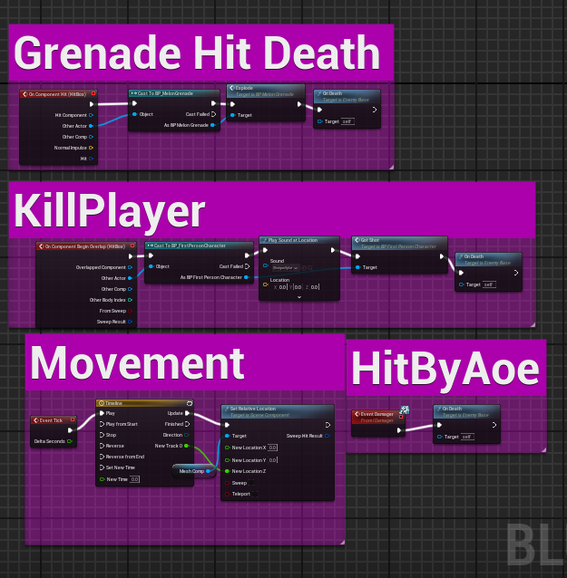
With the new EnemyBase class, the enemy blueprints now look like this. I planned to convert the rest of the functions into C++ too, but they held references to the weapon and player classes, and I did not have time to redo them.

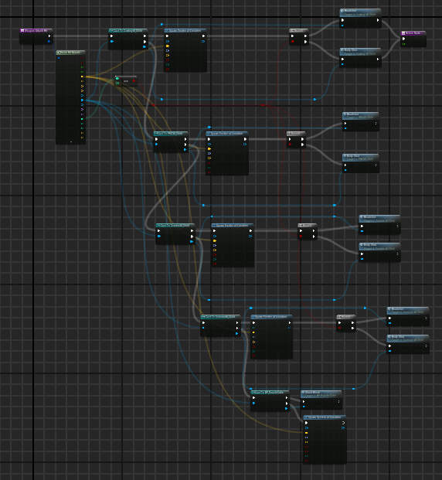
Blueprints
As the enemies had no parent class, the first iteration of the weapon blueprint would check each enemy type individually, which is inefficient.

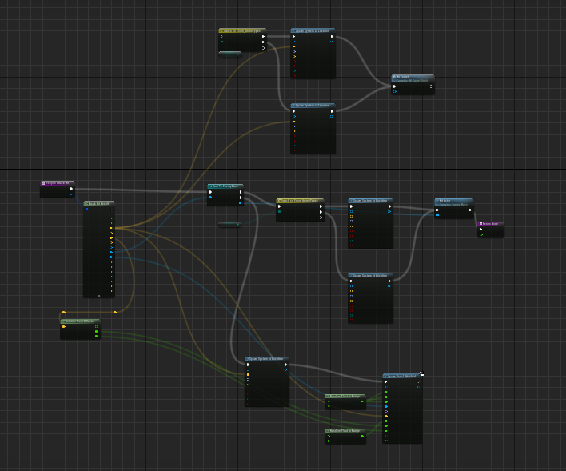
After the EnemyBase class was made, the weapon only needed to perform one check when interacting with an enemy.

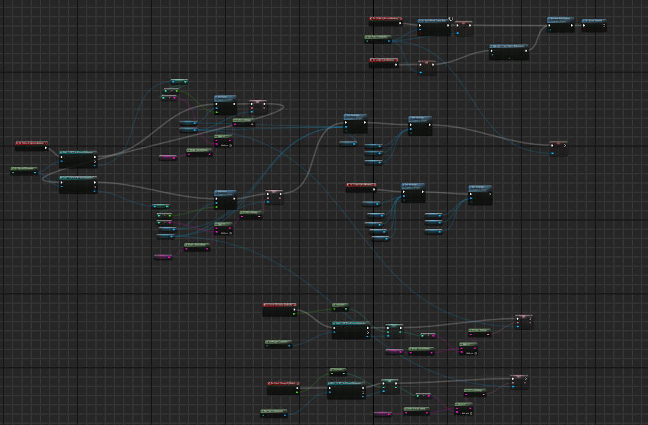
I also made the pause menu blueprint, with vertical and horizontal sensitivity options.

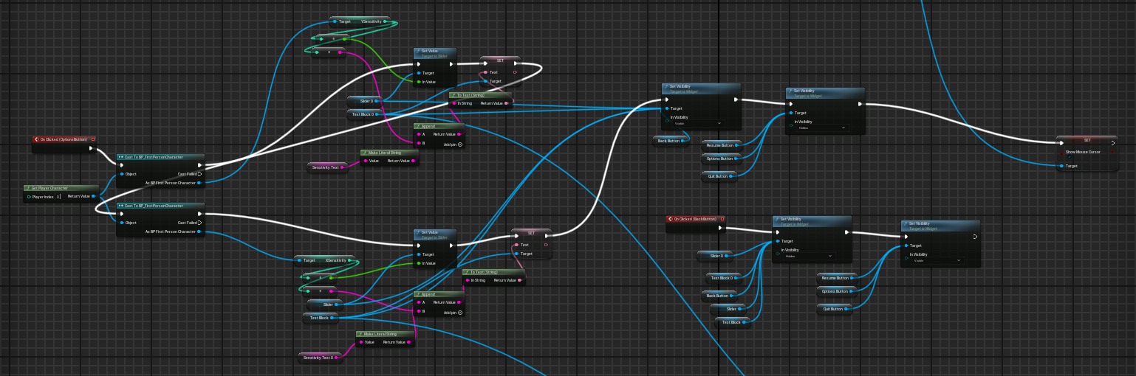
Blueprint to open/close the options menu. Also sets the sensitivity values to the currently used values.

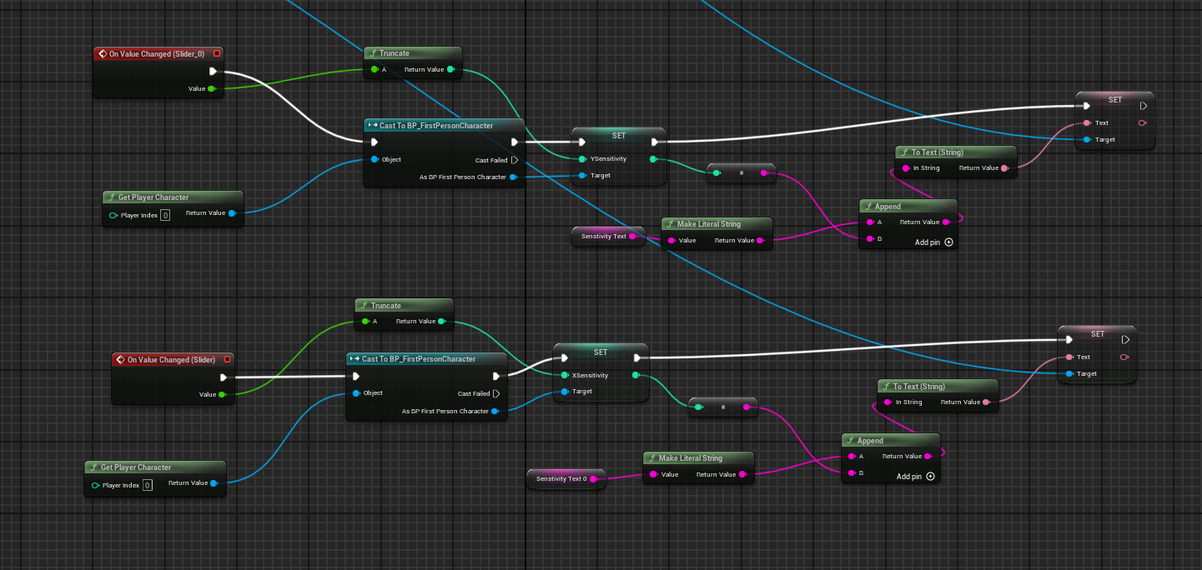
Blueprint to change the sensitivity values.

